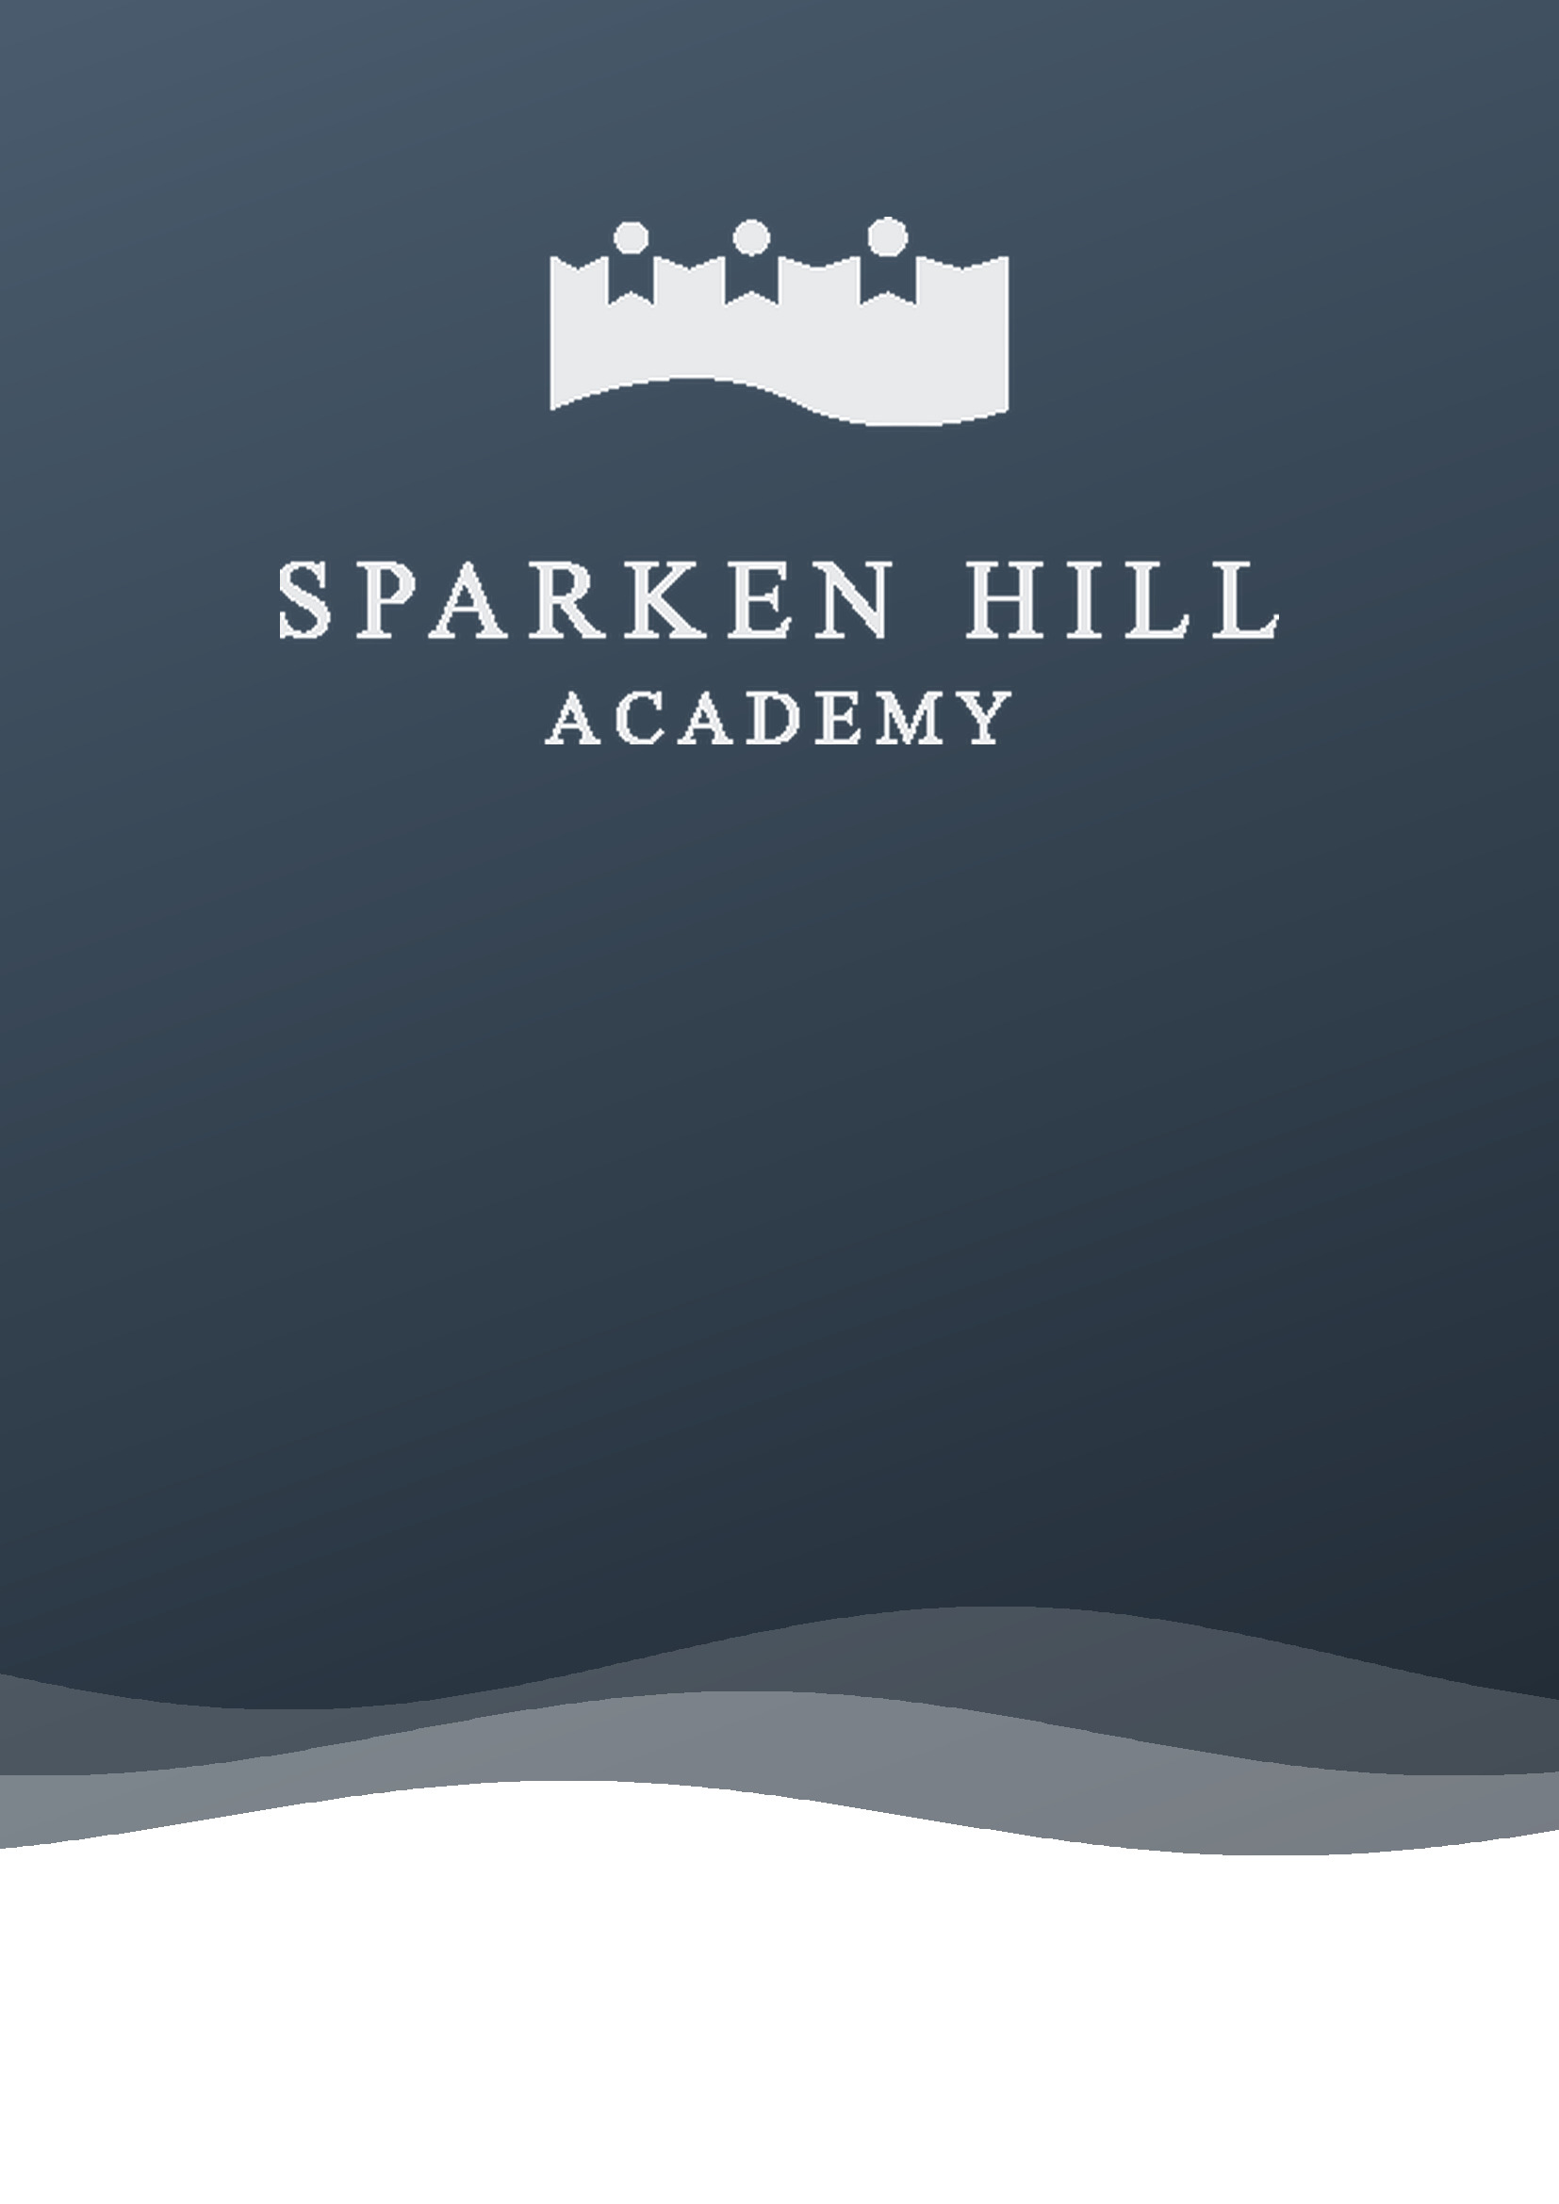
Public Consultation
Proposed Correction to our Net Capacity
Net capacity to reduce from 630 to 575. Our Published Admission Number stays at 75.
Autumn 2026

At a glance
Proposed change | Reduce the net capacity recorded in the Academy’s Funding Agreement from 630 to 575
What is not changing | Our Published Admission Number (PAN) stays at 75 Reception places each year
Proposed effective date | [September 2028, or on DfE approval if later]
Consultation period | Friday 23 October 2026 to 12 noon on Friday 18 December 2026
Lead contact | Mr Richard Lilley, Principal
Contact | office@sparkenhill.com | 01909 534060

1. Introduction and purpose of this consultation
Sparken Hill Academy is a standalone primary academy for pupils aged 3 to 11 in Worksop, Nottinghamshire. We currently have 517 pupils on roll from Nursery to Year 6.
Sparken Hill Academy Trust is consulting on a proposal to correct the net capacity recorded in the Academy’s Funding Agreement, reducing it from 630 to 575. This is not a change to our Published Admission Number (PAN). We will continue to admit up to 75 children into Reception each year.
We are seeking the views of parents, carers, staff, governors, the local community, neighbouring schools and Nottinghamshire County Council before any formal application is made to the Department for Education (DfE).
Please read this document carefully and send us your response using the details in Section 7.

2. Background

2.1 Net capacity and PAN: what is the difference?
 | Net capacity | Published Admission Number (PAN)
What it measures | How many pupils the whole building can accommodate, from Reception to Year 6 | How many children we admit into Reception each year
How it is set | Calculated using the DfE’s Net Capacity Assessment method and recorded in the Funding Agreement | Set by the Academy Trust in its admission arrangements
Current figure | 630 (recorded in error) | 75
Proposed figure | 575 | 75 (no change)

2.2 The school
School detail | Information
School name | Sparken Hill Academy
Phase | Primary (ages 3 to 11)
Address | Sparken Hill, Worksop, Nottinghamshire S80 1AW
Principal | Mr Richard Lilley
Pupils on roll (September 2026) | 517 (including 33 in Nursery)
Pupils in Reception to Year 6 | 484
Pupils with SEND | 100 (19.3%)
Eligible for free school meals | 236 (45.6%)
English as an additional language | 93 (18.0%)
Published Admission Number (Reception) | 75 (no change)
Net capacity: current figure | 630
Net capacity: proposed figure | 575

2.3 How the figure of 630 came about
When the Academy’s Funding Agreement with the Secretary of State was drawn up, the school’s capacity was recorded as 630 pupils. Following a review of the school’s accommodation, it is clear that this figure was recorded in error.
A Net Capacity Assessment of the school building has confirmed that it has enough teaching spaces for a maximum of 575 pupils from Reception to Year 6. The building was not designed or built for 630 pupils and does not contain the number of teaching spaces that figure would require.

2.4 Our current position
Our current roll is well below both the recorded figure of 630 and the proposed figure of 575.
Phase | Pupils on roll (September 2026)
Nursery (Foundation 1) | 33
Reception (Foundation 2) | 63
Years 1 and 2 | 144
Years 3 and 4 | 120
Years 5 and 6 | 157
Total, Nursery to Year 6 | 517
Total, Reception to Year 6 (counted in net capacity) | 484

The school has never operated at or near 630 pupils.

3. The proposal

3.1 What we are proposing
We propose to reduce the net capacity recorded in the Academy’s Funding Agreement from 630 to 575, so that it matches the school building’s actual capacity.
This is not a proposal to reduce the size of the school or to limit access for families. It corrects an error in the Funding Agreement.

3.2 What will not change
- Our Published Admission Number stays at 75. We will continue to offer up to 75 Reception places every year.
- We will continue to admit pupils into other year groups through in-year admissions where places are available.
- Our admission arrangements and oversubscription criteria are unchanged.
- No teaching spaces or facilities will be removed or reduced.
- Pupils already at the school are not affected.
- Our ethos, curriculum and values are unchanged.

3.3 Why we are proposing this change
- Accuracy. Our official figures should reflect the real capacity of the building. A Net Capacity Assessment confirms that 575 is the correct figure.
- Consistency. A PAN of 75 across seven year groups gives a maximum of 525 pupils. A net capacity of 575 is consistent with this; a figure of 630 is not.
- Reliable planning data. The DfE and Nottinghamshire County Council use capacity figures to plan school places across the area. Accurate figures support good local planning.
- Transparency. Parents and the local community should be able to rely on our published information.

4. Impact assessment

4.1 Pupils currently on roll
The proposal has no impact on any pupil currently at Sparken Hill Academy.

4.2 Future admissions
The proposal does not change the number of places we offer. With a PAN of 75, the most pupils we could have from Reception to Year 6 is 525, which is below the proposed net capacity of 575. No child who would be offered a place now would be refused a place because of this change.

4.3 Local place planning
The Academy Trust has discussed this proposal with Nottinghamshire County Council. The Trust is satisfied that:
- there is no current or projected shortage of primary places in the area that this change would make worse
- the school will continue to have enough capacity to meet the needs of its local community; and
- the change does not remove any places that are needed to meet local demand.

4.4 Equalities
The Academy Trust has had due regard to the Public Sector Equality Duty under the Equality Act 2010. As the proposal corrects a recorded figure and does not change our PAN or admission arrangements, the Trust does not consider that it will have an adverse impact on any group with protected characteristics.
Our admission arrangements continue to give first priority to looked after and previously looked after children, and children with an Education, Health and Care Plan that names the school will continue to be admitted.

5. Legal and procedural framework
An academy’s capacity is set out in its Funding Agreement with the Secretary of State. Changing it requires approval from the DfE under its guidance, Making significant changes to an existing academy. As part of that process, the Trust is expected to consult those affected and to share the outcome with the DfE.
As our PAN is not changing, our admission arrangements for 2028–29 are being consulted on separately, in line with the School Admissions Code.
After the consultation closes, the Trust will consider every response before deciding whether to apply to the DfE. Any application will include a summary of the consultation responses and the views of Nottinghamshire County Council. If the DfE approves the change, the Funding Agreement will be updated through a deed of variation, and the new figure will be reflected in future School Capacity (SCAP) returns.

6. Questions for consultation
You do not need to answer every question. Any feedback you can give is welcome.
Question | Your response
Q1. Do you support the proposal to reduce the Academy’s net capacity from 630 to 575? (Our PAN stays at 75.) | Yes / No / No strong view  Comments:
Q2. Do you have any concerns about the effect of this change on local school places or parental choice? | Yes / No  If yes, please give details:
Q3. Do you think any group of children or families would be disadvantaged by this change? | Yes / No  If yes, please give details:
Q4. Is there anything else you would like the Academy Trust to consider before making a final decision? | Comments:

7. How to respond
We welcome responses from everyone with an interest, including:
- parents and carers of children at the school, and of children who may attend in future
- staff and governors
- Nottinghamshire County Council
- neighbouring schools and academy trusts
- members of the local community
Consultation closes: 12 noon on Friday 18 December 2026
By email: office@sparkenhill.com, with the subject line “Net Capacity Consultation Response”
By post: FAO Chair of Governors, Sparken Hill Academy, Sparken Hill, Worksop, Nottinghamshire S80 1AW
In person: response forms are available from the school office
Questions: call 01909 534060 or email office@sparkenhill.com

The Academy Trust will consider every response before deciding whether to apply to the DfE. A summary of responses will be included in any application. Responses may be shared with the DfE as part of that application, but your personal details will not be published without your consent.

8. Timeline
Stage | Date
Consultation opens | Friday 23 October 2026
Consultation closes | 12 noon, Friday 18 December 2026
Trust considers responses | [January 2027]
Decision on whether to proceed | [
Application submitted to the DfE | [To be confirmed]
DfE decision | [To be confirmed]
Revised net capacity takes effect | [September 2028, or on DfE approval if later]

9. Further information
If you have any questions about this consultation, or would like to discuss the proposal, please contact:
Mr Richard Lilley, Principal
Sparken Hill Academy, Sparken Hill, Worksop, Nottinghamshire S80 1AW
Telephone: 01909 534060 | Email: office@sparkenhill.com

This document, the response form and the poster are also available on the Admissions page of our website, www.sparkenhillacademy.com. Paper copies, large print and translations are available from the school office.

