Date:-_________________________ Name:-_________________________
LO:- (Y5/6)To assess what we know about Light
transparent | ……………………………………………  …………………………………………….
translucent | …………………………………………….  …………………………………………….
opaque | …………………………………………….  …………………………………………….
reflection | …………………………………………….  …………………………………………….
luminous | ……………………………………………..  ……………………………………………..
Non-luminous | ……………………………………………..  ……………………………………………..
periscope | ……………………………………………..  ……………………………………………..
refraction | ……………………………………………..  …………………………………………….
prism | ………………………………………………….  ………………………………………………….
Visible spectrum | ………………………………………….….  ……………………………………………...
shadow | ……………………………………………..  ……………………………………………..
incidence | ……………………………………………..  …………………………………………..…
Light source | ....................................................  ……………………………………………..

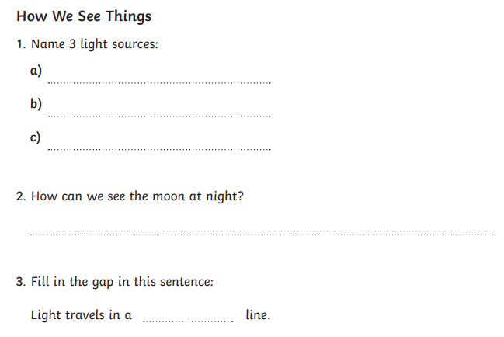
LO:- To assess disciplinary knowledge of the light curriculum statements



