Date:-_________________________ Name:-_________________________
LO:- To assess what we know about muscles and different skeleton types.
Vertebrate | ………………………………………  ………………………………………  ………………………………………
Invertebrate | ……………………………………….  ……………………………………….
Endoskeleton | ……………………………………….  ……………………………………….
Exoskeleton | ……………………………………….  ………………………………………
Voluntary  muscles | ……………………………………….  ……………………………………….
Involuntary muscles | ……………………………………….  ……………………………………….
Skeletal muscles | ……………………………………….  ……………………………………….
Cardiac muscles | ……………………………………….  ………………………………………
Biceps | ……………………………………….  ……………………………………….
Triceps | ……………………………………….  ……………………………………….
Skull | ……………………………………….  ………………………………………
Ribcage | ……………………………………….  ……………………………………….
Humerus | ………………………………………  ………………………………………
Femur | .............................................  ………………………………………
Tibia | ………………………………………  ……………………………………….  ………………………………………
Fibula | ……………………………………….  ……………………………………….  ………………………………………
Ulna | ……………………………………….  ……………………………………….  ………………………………………
Clavicle | ……………………………………….  ……………………………………….
Scapula | ……………………………………….  ……………………………………….
Radius | ……………………………………….  ………………………………………
Date:-_________________________ Name:-_________________________
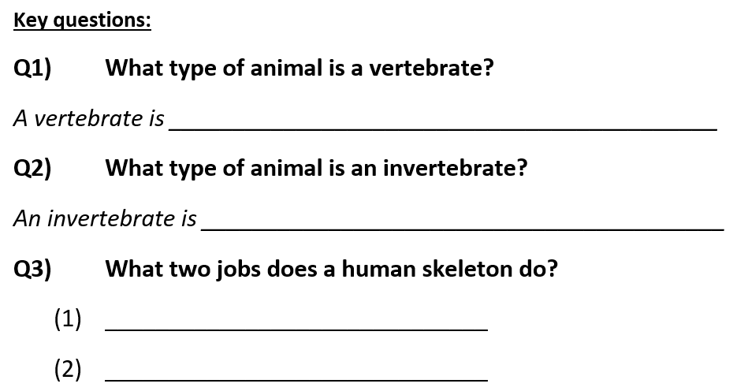
LO:- To assess disciplinary knowledge of muscles & different skeleton types.


