Date:-_________________________ Name:-_________________________
LO:- To assess what we know about seasonal changes (Y 1 / 2)
Season | ………………………………………  ………………………………………
Weather | ……………………………………….  ……………………………………….
Spring | ……………………………………….  ……………………………………….
Summer | ……………………………………….  ………………………………………
Autumn | ……………………………………….  ……………………………………….
Winter | ……………………………………….  ……………………………………….
Deciduous trees | ……………………………………….  ……………………………………….
Evergreen trees | ……………………………………….  ………………………………………
Weather forecast | ……………………………………….  ……………………………………….  …………………………………………
Day length | ……………………………………….  ……………………………………….
Sun rise / Sun set | …………………………………………  ………………………………………….  …………………………………………

Date:-_________________________ Name:-_________________________
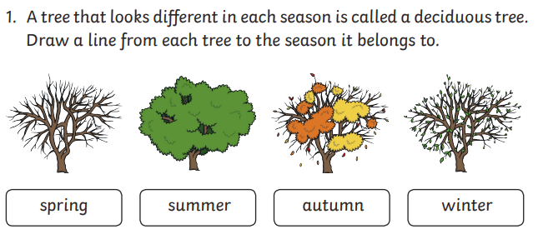
LO:- Year 1 / 2 To assess disciplinary knowledge of Seasonal Changes
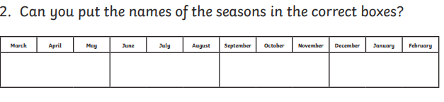

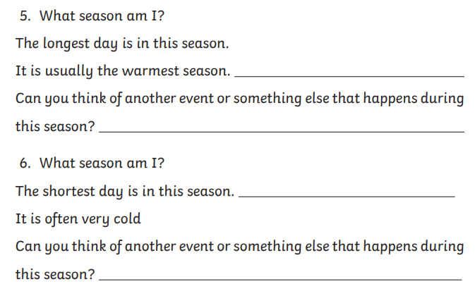
3.

4.

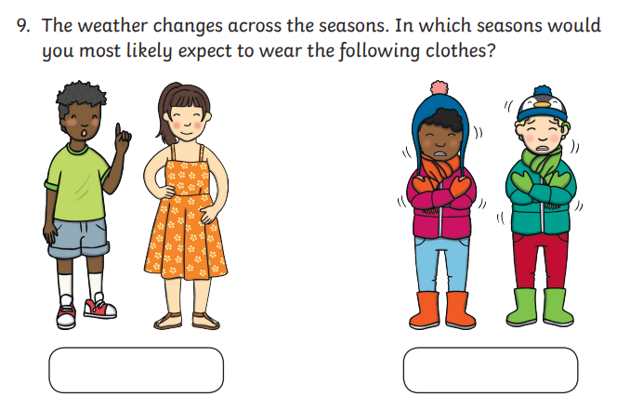
5.
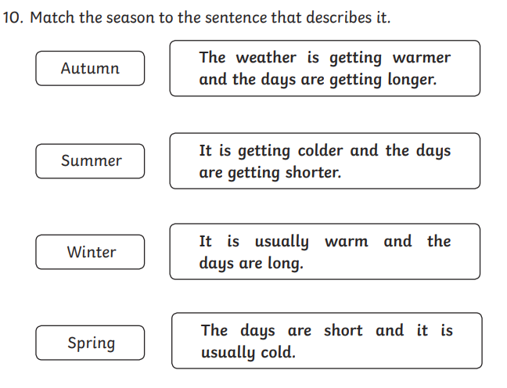
6.
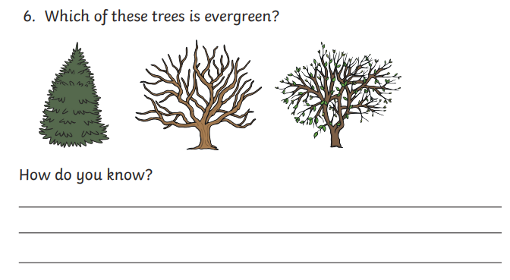
7.
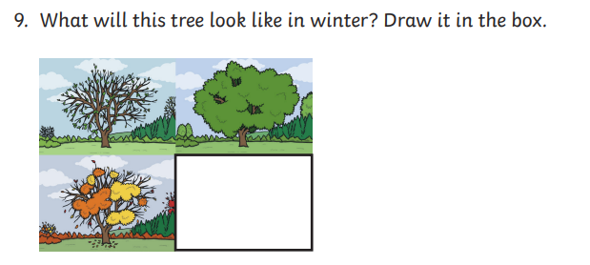
8.

