Date:-_________________________ Name:-_________________________
LO:- To assess what we know about teeth, food chains & environmental changes effects on living things
incisor | ………………………………………  ………………………………………
canine | ……………………………………….  ……………………………………….
molar | ……………………………………….  ……………………………………….
teeth | ……………………………………….  ………………………………………
Pre-molar | ……………………………………….  ……………………………………….
Food chain | ……………………………………….  ……………………………………….
producer | ……………………………………….  ……………………………………….
herbivore | ……………………………………….  ………………………………………
carnivore | ……………………………………….  ……………………………………….
omnivore | ……………………………………….  ……………………………………….
predator | ……………………………………….  ………………………………………
prey | ……………………………………
consumer | ………………………………………  ………………………………………
decomposer | .............................................  ………………………………………
scavenger | ………………………………………  ……………………………………….  ………………………………………
detritivores | ……………………………………….  ……………………………………….  ………………………………………
ecosystem | ……………………………………….  ……………………………………….  ………………………………………
biomes | ……………………………………….  ……………………………………….
climate | ……………………………………….  ……………………………………….
endangered | ……………………………………….  ………………………………………
extinct | ……………………………………….  ……………………………………….
habitat | ……………………………………….  ……………………………………….

Date:-_________________________ Name:-_________________________
LO:- To assess disciplinary knowledge of teeth, food chains & environmental changes effects on living things

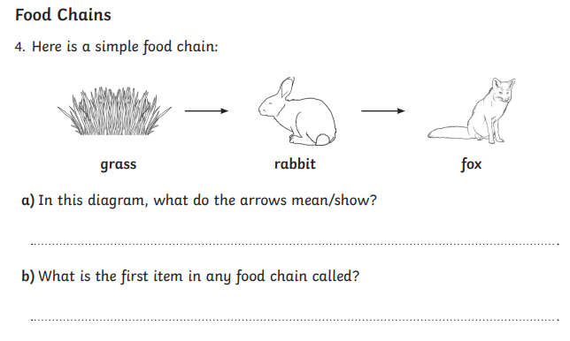
1.

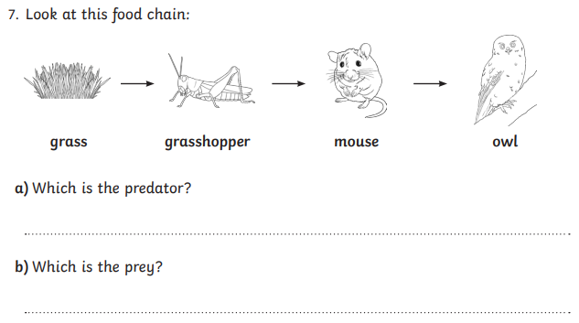
2

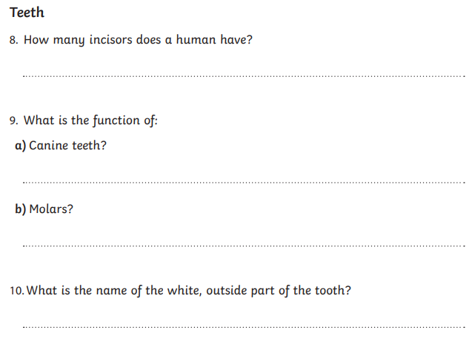
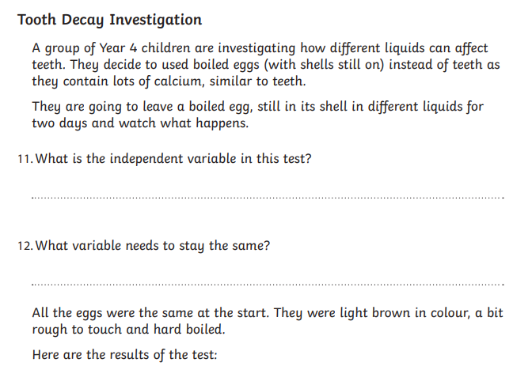
7
6
5
4
3

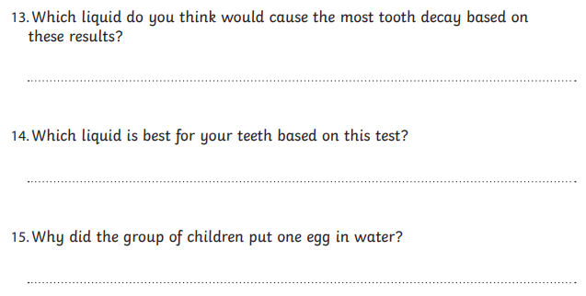
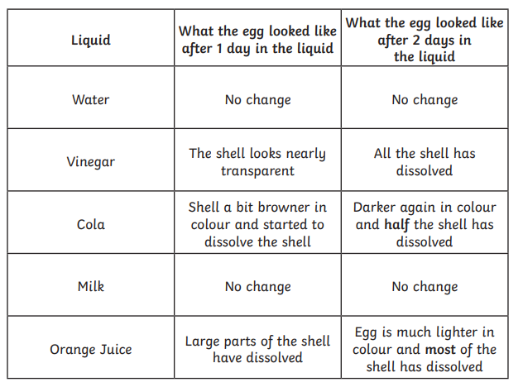
10
9
8



