Date:-_________________________ Name:-_________________________
LO:- To assess what we know about Everyday Materials & their properties (Y2)
Man-made materials | ………………………………………  ………………………………………  ………………………………………
Natural materials | ……………………………………….  ……………………………………….
opaque | ……………………………………….  ……………………………………….
transparent | ……………………………………….  ………………………………………
translucent | ……………………………………….  ……………………………………….
waterproof | ……………………………………….  ……………………………………….
absorbent | ……………………………………….  ……………………………………….
magnetic | ……………………………………….  ………………………………………
flexible | ……………………………………….  ……………………………………….
Hard | ……………………………………….  ……………………………………….
stretchy | ……………………………………….  ……………………………………….

Date:-_________________________ Name:-_________________________
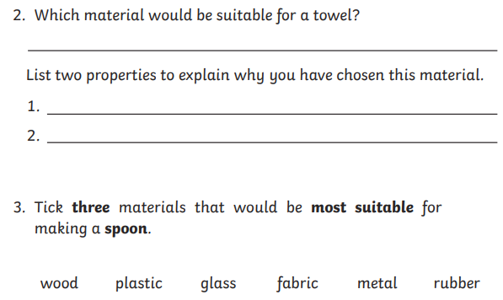
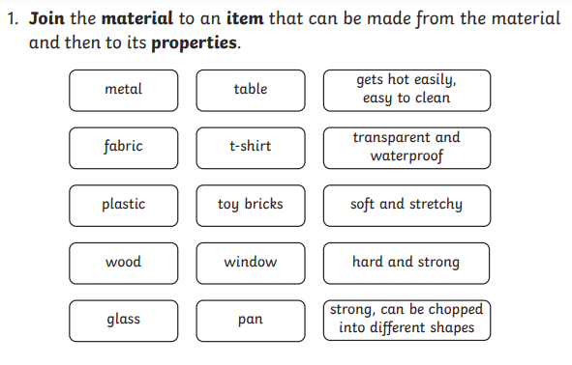
LO:- Year 2 To assess disciplinary knowledge of everyday materials and their properties



