How can we assess knowledge?

Before we can discuss how to assess knowledge, we must first define what knowledge is. With regards to teaching, I believe in a rather simplistic dichotomy of knowledge: substantive and disciplinary.
Substantive knowledge is the knowledge produced by any specific academic subject. It is therefore sometimes referred to as ‘content’ knowledge. It is the knowledge you learn from a topic or unit. In science, this might be what respiration is. In geography, it might be about the economic development of a region. In art, it might be the style of Impressionism. You get the idea. Substantive knowledge is the knowledge children gather as established fact. The concepts, the words, the dates and so on.
In contrast, disciplinary knowledge is the understanding of how that knowledge was formed, how it continues to be formed and a general understanding of how that subject manifests itself and operates. In science, this may be understanding how a scientific investigation is conducted. In geography, this could be an understanding of how geographical fieldwork is undertaken. In history, it could be how we gather information from historical sources. Disciplinary knowledge is understandably harder to teach and arguably less common in classroom assessments than it is in external assessments (e.g. GCSEs). I am proposing we address this imbalance.
We need to think about the validity and reliability of the assessments we use with regards to these two types of knowledge. If our assessment only tests substantive knowledge, then has the pupil learnt about how the discipline itself operates? Likewise, if the assessment only tests the disciplinary knowledge, can we truly know if the pupils have learnt the content of the topic and successfully added to their schema of pre-existing knowledge? Therefore, arguably, our assessments must provide opportunity to assess both types of knowledge together or assess them individually. I suggest the latter.
Previously, at my school, we (regrettably) used KWL grids to assess children’s progress through a topic. A KWL grid assesses what a child knows ( K ), what a child wants to know ( W ) and what they have learnt ( L ). I always found the W section to be particularly frustrating, as children will always write the most absurd questions here that you never get any time to address in depth, or you simply don’t know the answer to because your limited subject knowledge exists outside the realm of their wild imagination and its far-fetched questions. So then, what is the point in allowing children to ask these questions?
We believed these assessments showed progression in children’s learning simply because the third column had more writing than the first column, but this was no real indicator of children being successful in their learning long-term. Moreover, there are many problems with an assessment of this type. First, they seem to only test substantive knowledge, as they only ask children to recall what they know. Secondly, the opportunity for recall is rather lacking. Just asking children to write down everything they remember without any retrieval cues is unsurprisingly rather ineffective. For us, we needed to ensure our assessments were more effective in the foundation subjects.
An example of a blank KWL grid:
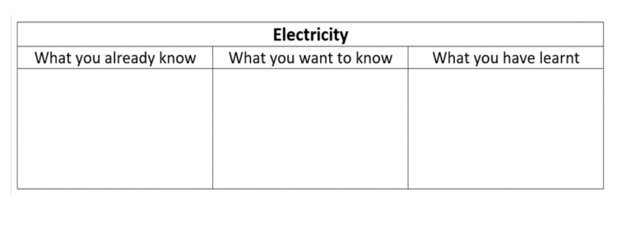
I will use my most recent history topic of the Great Fire of London to model the two separate assessments we came up with.
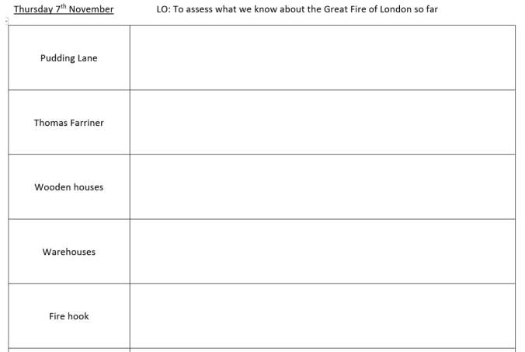
Testing substantive knowledge – vocabulary wordbank. Children are provided words from the topic and then asked to write down what they know about them. These act as retrieval cues, rather than simply asking children to write down everything they know about a topic with no prompts. If they can’t think of anything, they simply leave it blank so the teacher is aware of what needs to be revisited. Children write in as much or as little detail as they can. The teacher can then assess their understanding by looking at the level of detail in their answer and how well they have linked it to other words and concepts learnt.

Testing disciplinary knowledge – answering questions linked to the discipline itself. This would always be conducted subsequent to the assessment on substantive knowledge, because children would need to draw on that substantive knowledge to help them. This assessment would focus on unpicking the elements of the subject discipline we wanted them to grasp (e.g. for history, that could be how historical knowledge has accumulated over time, the reliability of sources or the correlation between cause and effect). Below is an example of this type of assessment. Next to each question in red, I have added the disciplinary knowledge each question sought to assess. Children would be given more space to write their answers for this assessment, as it would provide more scope for more detailed answers.
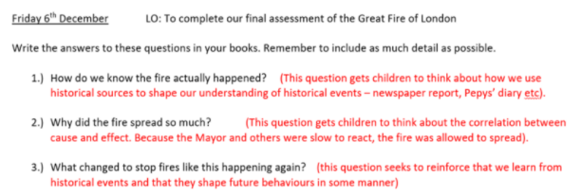

With the recent emphasis on retrieval practice in education forums, it would be easy to ignore disciplinary knowledge and focus solely on substantive knowledge. But, both types of knowledge are equally as important as one another. They are inextricably linked and inform one another. Together, they allow children to formulate a schema of knowledge that allows them to understand and interpret each subject, as well as the world around them.

Assessment
They were also particularly impressed with how we assess in science. We do two different assessments.
An assessment of substantive knowledge – children define keywords and give examples.
An assessment of disciplinary knowledge – children answer questions using their scientific knowledge to come to a conclusion.
Below I have shared a picture of both types of assessment.
Assessment on substantive knowledge – keywords:

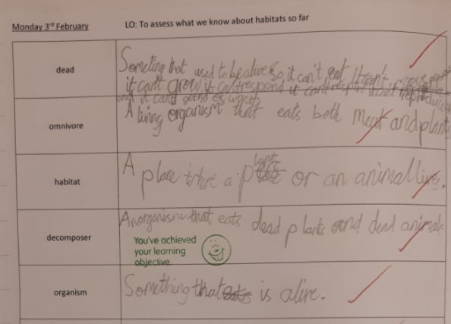

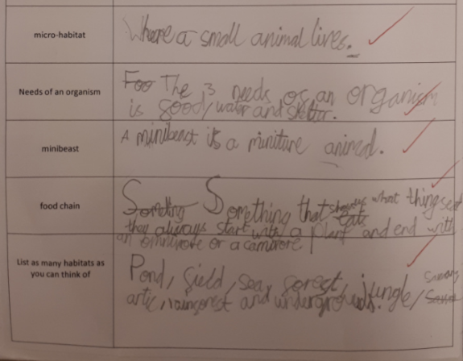

Assessment on disciplinary knowledge – questions to show scientific understanding:



