Progression of Enquiry Skills from Early Years Foundation Stage to Key Stage One

EYFS Key Stage One

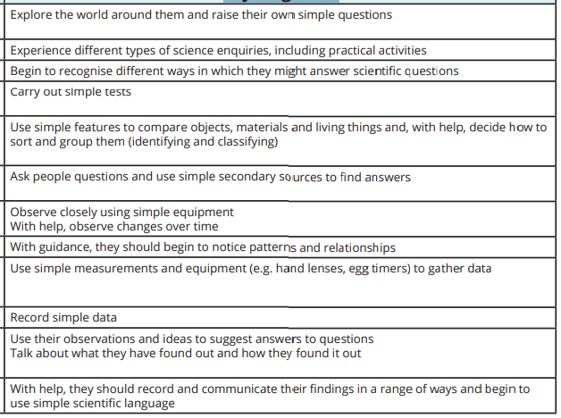
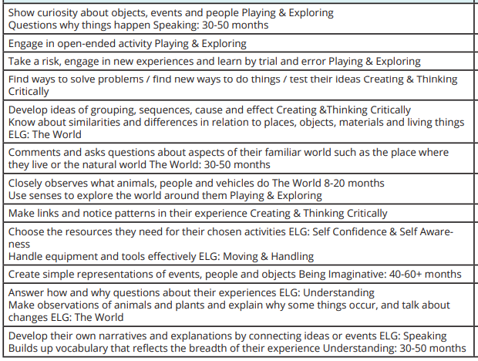

Progression of Enquiry Skills from Key Stage One to Key Stage Two
Key Stage One Lower Key Stage one Upper Key Stage Two
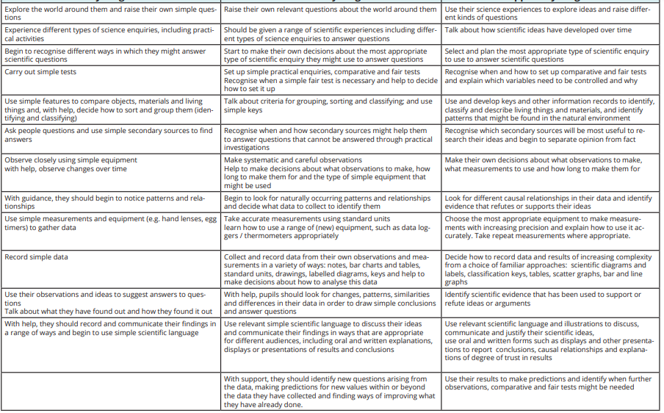

Upper Key Stage 2 Key Stage 3
Progression of Enquiry Skills from Key Stage Two to Key Stage Three


