Reading at Sparken Hill Academy - Intent
At Sparken Hill Academy, we are dedicated to enabling our pupils to become lifelong readers and we believe reading is key for success academically and beyond.
The overarching aim for our English curriculum is to promote high standards of language and literacy by enabling pupils to develop a strong command of the spoken and written word, and a love of literature through widespread reading for pleasure.
Empower
High quality and challenging texts ensure that children are exposed to advanced language and rich vocabulary; they explore and discuss mature themes and make connections with the wider world. Our children are empowered to develop communication skills for education and for working with others: in school and beyond.
Respect
An increasingly diverse and varied range of books throughout our curriculum open doors to social diversity, broadening children’s experience of different cultures and experiences and understanding a character’s point of view. Our children leave us as respectful citizens with the confidence to discuss what makes all of us unique, valued and respected in terms of culture, race, ethnicity, gender, education, disability, identity, nationality, religion, sexuality, neurodiversity, social background, and beliefs.
Care
Children who find reading difficult are likely to struggle across the curriculum. In line with our vision to inspire, to raise aspiration and to create brighter tomorrows, we are determined that every child will learn to read, regardless of their background, needs or abilities. The teaching of reading is prioritised to ensure that our children read widely and develop fluency, confidence, and enjoyment of reading.

At Sparken Hill Academy, we are determined that:
- Every child will learn to read, regardless of their background, needs or abilities.
- All children, including the weakest readers, make sufficient progress to meet or exceed age-related expectations.
- Children will be familiar with, and enjoy listening to a wide range of stories, poems, rhymes and non-fiction.
- Children acquire a wide vocabulary and develop language comprehension, as we nurture a love of reading through stories, poems, rhymes and non-fiction.
- Children develop the habit of reading widely and often, for both pleasure and information;

At Sparken Hill Academy we have developed an English curriculum that is:
- ambitious for all pupils;
- coherently planned and sequenced around an agreed, progressive reading spine;
- successfully adapted, designed and developed for pupils with special educational needs and / or disabilities;
- broad and balanced for all pupils.

Implementation

Phonics Bug
The academy follows the DfE accredited Pearson Phonics Bug program from F1 to Year 2 (see phonics policy). Phonics Bug lessons take place first thing in the morning across the Early Years and Key Stage 1 classes. The Phonics Bug philosophies are embedded in the teaching and learning of reading and writing throughout the curriculum. The use of this synthetic phonics program ensures that all children are taught:
- phonemic awareness (the sounds that make up words such as c/a/t);

- the sound–spelling relationships in words;
- how to say the sounds that make up words; and to do this by:
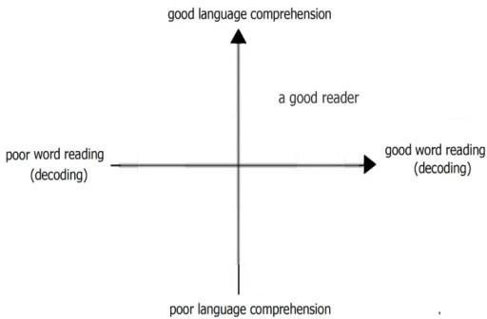
- using texts that are made up of words that use the sound–spelling relationships children have learned;
- using interesting and authentic stories to develop vocabulary and language comprehension.
Children are assessed regularly and placed in groups according to their assessment. This ongoing assessment of pupils’ phonics progress is sufficiently frequent and detailed to identify any pupil who is falling behind the programs pace. If they do fall behind, targeted support is given immediately. The school has clear expectations of pupils’ phonics progress term-by-term, from Reception to Year 2, through the use of an online phonics tracker which is updated half-termly. Records of attainment and progress are kept using “Phonic Tracker” Software
Children whose reading is below expectations for their age, including those with special educational needs or with English as an Additional Language, receive intensive individual or small-group intervention.
School leaders, the SENDCO and teaching staff work together to make sure all of these pupils make rapid progress. The Simple View of Reading is used to determine whether children have difficulty with word reading, language comprehension or both of these, and the correct intervention is put in place and monitored closely.

Learning to read – individual reading pathway
The sequence of reading books shows a cumulative progression in phonics knowledge that is matched to the school’s phonics programme. Teachers prioritise the sufficient practice in reading and re-reading books that match the grapheme-phoneme correspondences they know, both at school and at home.
Once children are reading fluently, they move to the Accelerated Reader reading book system.
At the beginning of each half term, pupils take a Star Reading Test. This then informs the pupils ZPD range. Teachers use their professional judgement in order to specify the range within the ZPD that the pupils will choose. Pupils are encouraged to read their book at school and at home and to take a quiz at the end to test their understanding of what they have read.
Alongside this we also operate MyOn, which is an online library. There is a vast array of texts and genres for the pupils to choose, all of which also have ZPDs. The Accelerated Reader system links to this and also allows online tests for every text on the system.
Over the half term, staff monitor the pupil’s reading via their reading diaries and online reports. Regular reading is monitored along with the text types they are choosing, along with their results from their AR quizzes. Necessary steps can then be taken to address any areas for development, such as frequency of reading, comprehensions of text or lack of breadth in reading.
Home reading is strongly encouraged at least three times per week and families are asked to record this in reading diaries.

Reading to learn – whole class teaching of reading
In Early Years and Year 1, there is frequent shared, guided and individual reading of stories, poems, rhymes and non-fiction which are chosen for reading to develop pupils’ vocabulary, language comprehension and love of reading. Pupils are familiar with identified key texts in each year group and they enjoy listening to a wide range of stories, poems, rhymes and non-fiction from F1 upwards. These sessions happen daily.
In Year 2 up, the guided / whole class shared reading approach is introduced for pupils who are ready to access it. This is dependent on their individual reading ability. The reading is structured around a set of strategies called VIPERS. These sessions happen daily, at least 4 times per week, in addition to the English lesson.
Children who cannot access the text are either read to by an adult or they access a phonics group as an intervention.

What are Reading VIPERS?

VIPERS is an acronym to aid the recall of the 6 reading domains as part of the UK’s reading curriculum. They are the key areas which we feel children need to know and understand in order to improve their comprehension of texts.
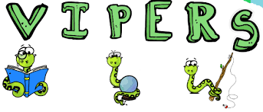
VIPERS stands for
Vocabulary
Inference
Prediction
Explanation
Retrieval
Sequence or Summarise
The 6 domains focus on the comprehension aspect of reading and not the mechanics: decoding, fluency, prosody etc. As such, VIPERS is not a reading scheme but rather a method of ensuring that teachers ask, and students are familiar with, a range of questions. They allow the teacher to track the type of questions asked and the children’s responses to these which allows for targeted questioning afterwards.
In addition to this we use the FFT Lightning Squad Reading programme to support pupils who are identified as needing further support with their reading, to help them reach their age related expectations and full potential as readers. This also supports their ability to read to learn, in all curriculum areas.

Reading for pleasure
Sparken Hill Academy is committed to enriching its practice, making stronger links with parents around reading and ensuring all staff are well positioned to nurture life-long readers.
Dedicated time for reading aloud to children is prioritised through the academy, following a progression of recommended key texts in addition to texts chosen by children from class collections. This occurs at the end of each day where time is dedicated to read to the class.

Suggested Activities – These should be varied and chosen to suit your class and their needs.

This is not an exhaustive list and alternative activities can be used as long as they support pupils towards the learning focus.
Session 1 –  Key focus:  Vocabulary  Sequence  Summarise | Introduce the text – This is the most important lesson and crucial to support pupils to be able to efficiently read to understand. | - First look/read – pupils could read independently, in pairs or as a class/group  - Clarify key vocabulary and ensure a full understanding of the main themes of the text (this should be the main focus for this session  - Discuss the text, likes, dislikes etc.
Session 1 –  Key focus:  Vocabulary  Sequence  Summarise |  | - Summarise main points/key themes/ideas of the text  - Discuss and clarify chosen vocabulary that ensures a fuller understanding of the text and expands vocab  - Find interesting facts/information you have found  - Pupils reading parts of the text aloud to the class with a focus on fluency and expression  - Sequencing the main/key ideas of the text.  - True or false questions about the text
Session 2  Vocabulary  Retrieval  Explain | Explore and find/retrieve information from the text | - Recap vocabulary  - Pupils write key vocabulary in alternative sentences to show understanding  - Retrieval questions – Skim & scan focus  - Explain questions – focus on ability to explain answers fully using evidence from the text.
Session 3  Vocabulary  Retrieval  Inference | Infer meaning from the text | - Recap vocabulary  - Inference questions  - Give reasons for authors choice of language and vocabulary – explore impact on the reader  - Begin to challenge points of view through discussions and debates  - Infer characters thoughts and motives, giving evidence to support points made  - Discuss how characters change and develop through texts by drawing inferences based on indirect clues
Session 4  Summarise  Retrieval  Predict | Summarise and make predictions | - Summarising questions  - Make predictions and support predictions based on evidence/information from the text.  - Confirm and modify predictions in light of new information as each part if read.  - Summarise entire texts/chapters/paragraphs, using a limited amount of words or paragraphs.

Core text reading spine (Odd Cycle)

Years FS | 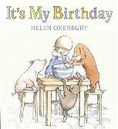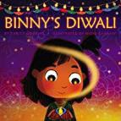  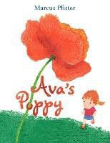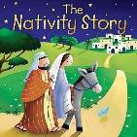 | Its My Birthday | 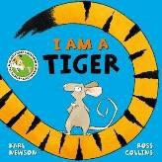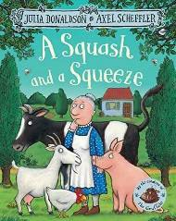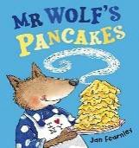  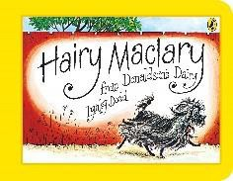 | The Storm Whale | 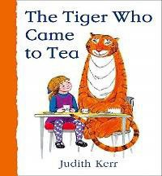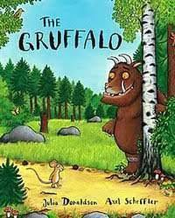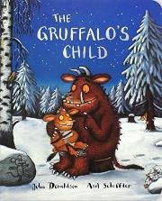 | The Tiger Who Came To Tea By Judith Kerr  Non fiction – animals  Robin Hood Gruffalo  By Julia Donaldson  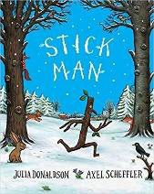  Gruffalo’s Child By Julia Donaldson  Stickman  By Julia Donaldson
Whole class reads and topic based texts (combined) |  | By Helen Oxenbury  Binny’s Diwali  By Thrity Umringar  Kipper’s Birthday |  | By Benji Davies  I Am A Tiger  By Karl Newson  A Squash & A Squeeze
 |  | By Mick Inkpen |  | By Julia Donaldson
 |  | Ava’s Poppy |  | Mr Wolf’s Pancakes
 |  | By Marcus Pfister |  | By Jan Fearnley
 |  | The Nativity Story By Juliet David |  | Hairy Maclary By Lynley Dodd
 | In FS, the book choices are fluid, due to pupil led learning and enquiry. This may lead to slight additions or amendments to the reading texts.
Years 1/2  Whole class reads | 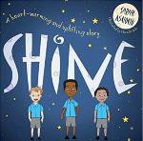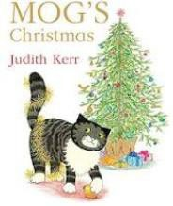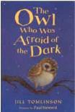 | Shine By Sarah Asuquo  Mogs Christmas By | 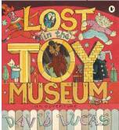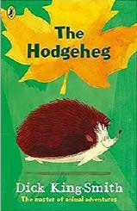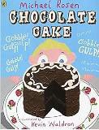 | Lost In The Toy Museum  By David Lucas | 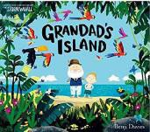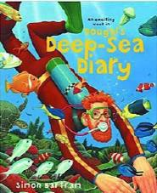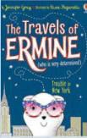 | Grandads Island By Benji Davies
Years 1/2  Whole class reads |  | Judith Kerr  The Owl Who Was |  | The Hedgehog By Dick King Smith |  | Douglas the Deep Sea Diary By Simon Bartram
Years 1/2  Whole class reads |  | Afraid Of The Dark

 |  | By Jill Tomlinson |  | Chocolate Cake By Michael Rosen |  | The Travels Of Ermine By Jennifer Gray,
Years 1/2  Topic based texts | 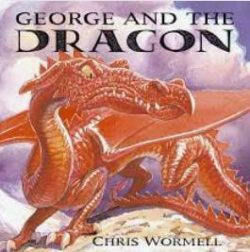  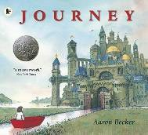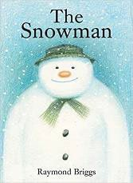 | George & The Dragon  Chris Wormelll | 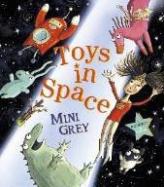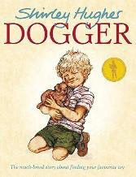  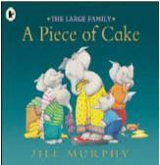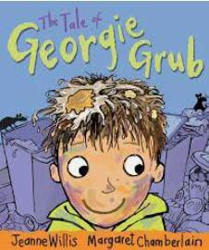 | Dogger  By Shirley Hughes Toys In Space  By Mini Grey  A piece of Cake By Jill Murphy  The Tale of Georgie Grub  By Jeanne Willis | 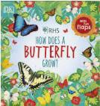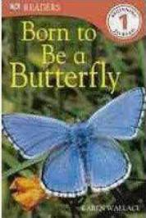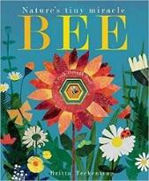  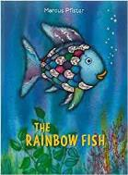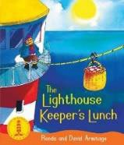 | Bee  By Patricia Heggarty
Years 1/2  Topic based texts |  | The Journey |  |  |  | RHS How Does A Butterfly Grow?
Years 1/2  Topic based texts |  | By Aaron Becker  The Snowman  By Raymond Briggs |  |  |  | Born To Be A Butterfly by Karen Wallace
 |  |  |  |  |  | The Lighthouse Keepers Lunch By David Armitage
Years 1/2  Topic based texts |  |  |  |  |  | The Rainbow Fish By Marcus Pfister

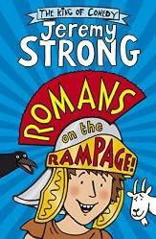
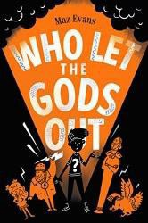
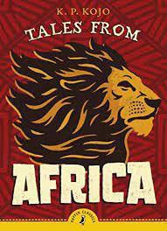
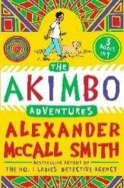
Years 3/4  Whole class reads | The Akimbo Adventures By Alexander McCall Smith  Tales From Africa By KP Koju |  | Romans On The Rampage  By Jeremy Strong  Who Let The Gods Out  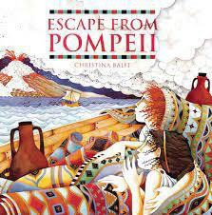  By Maz Evans |  | Fantastic Mr Fox By Roald Dahl  Why The Whales Came  By Michael Morpurgo | 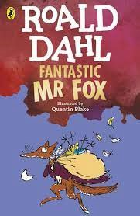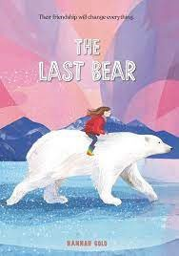
Topic based texts | 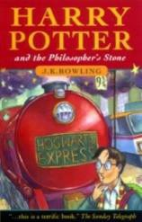  As above |  | Escape From Pompeii  By Christina Bailt  The Quest  By Aaron Becker |  | 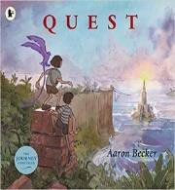  Is Plastic Fantastic?  A Place For Plastic By Twinkl | 
Year |  | 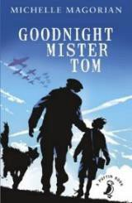  Harry Potter & The Philosophers Stone By JK Rowling  Goodnight Mr Tom By Berlie  Doherty | 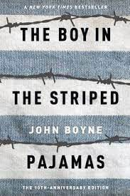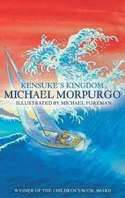 | Boy In The Striped Pyjamas  By John Boyne  Kensuke’s Kingdom By Michael Morpurgo | 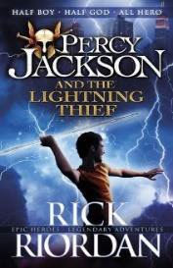 | Percy Jackson And
5/6 |  |  |  |  |  | The Lightening Thief
Whole class |  |  |  |  |  | By Rick Riorden
reads and topic
based texts
(combined)

Core text reading spine (Even Cycle)

Years FS  Whole class reads and topic based texts (combined) | 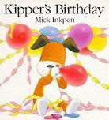 | Non-fiction books about Celebrations  Its My Birthday  By Helen Oxenbury  Binny’s Diwali  By Thrity Umringar  Kipper’s Birthday By Mick Inkpen  Ava’s Poppy  By Marcus Pfister | 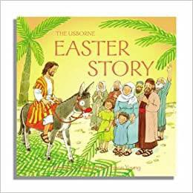 | Non-fiction books about our town  Non-fiction books about jobs/PWHU Maps  The Easter Story | 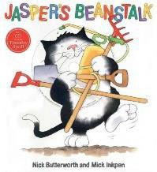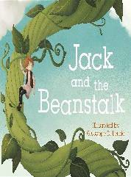 | Jasper’s Beanstalk By Nick Butterworth  Jack & the Beanstalk  Non-fiction books about minibeasts and growing plants/vegetables
 | In FS, the book choices are fluid, due to pupil led learning and enquiry. This may lead to slight additions or amendments to the reading texts.
Years 1/2  Whole Class Reads | 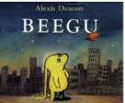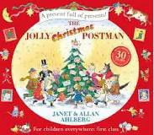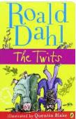 | Beegu By Alexis Deacon | 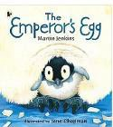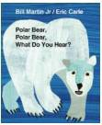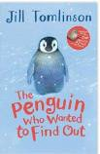 | The Emperor’s Egg By Martin Jenkins | 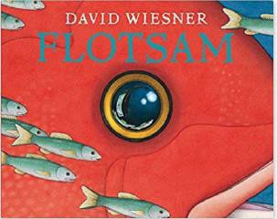 | Wangari’s Trees Of Peace by Leanette Winter
Years 1/2  Whole Class Reads |  | The Jolly Postmans |  | Polar Bear Polar Bear What Do |  | Floatsam by David Wiesner
Years 1/2  Whole Class Reads |  | Christmas |  | You Here?
Years 1/2  Whole Class Reads |  | By Janet & Allan Ahlberg |  | By Erice Carle |  | Amazing Grace By Mary Hoffman
Years 1/2  Whole Class Reads |  | Tomlinson |  | The Penguin

 |  | The Twits – Roald Dahl |  | Who Wanted To Find Out By Jill Tomlinson | 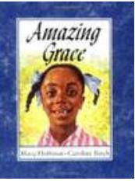
Topic based texts | 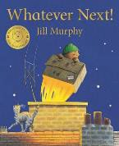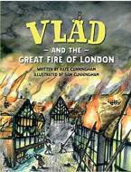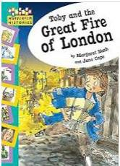 | Whatever Next | 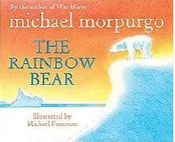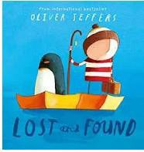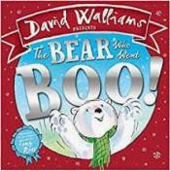 | The Rainbow Bear By Michael Murpurgo.  Lost & Found Oliver Jeffers  Polar Animals By  The Bear that went Boo By David Walliams | 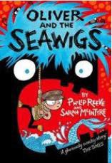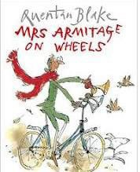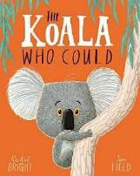  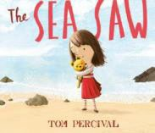 | Oliver & The Seawigs  By  Mrs Armitage on Wheels by Quentin Blake  The Koala Who Could  By Rachel Bright Diary of a Wombat  The Sea Saw By
Topic based texts |  | By Jill Murphy
Topic based texts |  | Man on the
Topic based texts |  | Moon
Topic based texts |  | By Simon
Topic based texts |  | Bartram
Topic based texts |  | Vlad By Kate
Topic based texts |  | Cunningham
Topic based texts |  | Toby & The
Topic based texts |  | Great Fire
Topic based texts |  | of London
Topic based texts |  | By
Topic based texts |  | Margaret
Topic based texts |  | Nash
Years 3/4  Whole class reads | Charlie And The Chocolate Factory  By Roald Dahl  The Explorer | 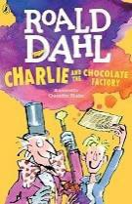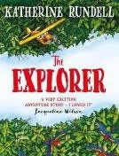 | Stone Age Boy  By Satoshi Kitamura  Stig Of The Dump By Clive King | 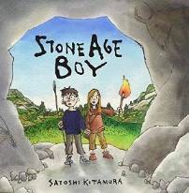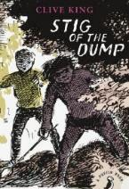 | Beowolf  By Michael Morpurgo  How To Train Your Dragon  By Cressida Cowell | 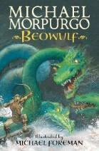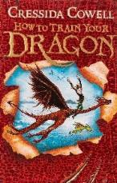

 | By Katherine Rundell
Topic based texts | The Great Kapok Tree  By Lynne Cherry | 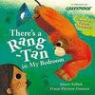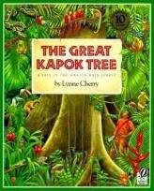 | As Above |  | As Above
Topic based texts | There’s A Rangtan In My Bedroom  By James Sellik
Year 5/6 | 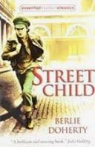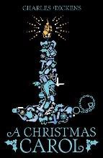 | Street Child By Berlie Doherty | 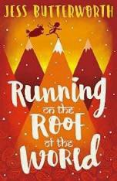 | Running On The Roof Of The World By Jess Butterworth | 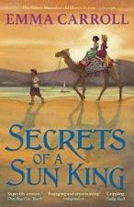 | Secrets Of The Sun King  By Emma Carroll
Whole class reads and topic based texts (combined) |  | A Christmas Carol By Charles Dickens |  | 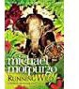  Running Wild By Michael Morpurgo |  | Secrets Of The Sun King  By Emma Carroll

Progression in reading

Child as a reader
Year 1 | Year 2 | Year 3 | Year 4 | Year 5 | Year 6
Is increasingly familiar  with a | Is increasingly familiar | Is increasing their | Can discuss a  range of | Gives developed detail  in | Can use appropriate  decoding
wide range of poems, | with a wide range of | familiarity with a wide | books and texts that | discussion about a range of | strategies fluently and
stories, fairy stories and | stories, fairy stories and | range of books (including | they have read, | texts, including personal | accurately
traditional tales | traditional tales | fairy stories, myths and | explaining key | opinion | Can skim texts to get the
Is developing pleasure in | Developing pleasure in | legends) and retelling some | information and giving | Explains different reasons | general idea of the content of
reading | reading | of these orally | their opinion about it | for reading, including for | a piece
Can recognise rhymes and | Can participate in | Can read for enjoyment | Is able to choose | enjoyment | Can scan texts to find
some simple poems | discussion about both books that  are read to | and chooses to read (canabsorb  themselves in a | books that they enjoyand will  challenge | Perseveres with challengingtexts | particular informationCan  read aloud with
 | them and those they read | book/text) | them | Can read and discuss the | intonation that shows
 | for themselves | Can recognise some | Is familiar with | construction and meaning | understanding
 | Can recognise recurring | different forms of poetry | different types of | of different types of poetry | Can construct visual images
 | literary language in poems | (for example, free verse, | poetry | Can compare and evaluate | Can compare, contrast and
 | and stories | narrative poetry) | Recognises similarities | different texts against their | evaluate different texts
 |  | Can read books that are structured in different ways | and differences between  texts | intended purpose | Can talk about the types oftexts they enjoy and that
 |  | and comment on their | structured in different |  | interest them
 |  | structures | ways |  | Can persevere with
 |  | Can read for a range of | Uses reading as a |  | challenging texts (whole

 |  |  | tool |  | texts,
 |  | purposes | to support other |  | including novels) to read with
 |  | Can use a dictionary to | aspects of learning |  | fluency, understanding and
 |  | check the meaning of | Understands when  it |  | expression
 |  | words they have read | would be helpful to
 |  |  | use a dictionary to
 |  |  | support reading

Word reading, decoding and understanding |  |  |  |  | Give/explain the meaning of words in context
Year 1 | Year 2 | Year 3 | Year 4 | Year 5 | Year 6
Can apply phonic  knowledge as | Can decode unknown | Can decode unknown  words | Can read age | Reads with fluency and | Can show an understanding  of
a route to decode words | words applying phonic | rapidly and without undue | appropriate texts with a | stamina | the meaning of vocabulary in
Can recognise, read and identify | knowledge | hesitation | good level of fluency | Can use a range of strategies | different contexts
correct sound to grapheme for | Can recognise, read and | Can recognise, read and | and stamina | to decode unfamiliar words | Can find and copy one
all 40+ phonemes | identify the full range of | identify the full range of vowel | Can use a range of | without impacting on overall | word/groups of words with a
Can recognise, read and identify | vowel graphemes | graphemes | strategies to decode | fluency | particular meaning
alternative sounds for some | Can recognise, read and | Can recognise, read and | unfamiliar words | Can read and understand the | Can find words in a text that
graphemes | identify the full range of | identify the full range of | Can read and | meaning of words with | most closely match the meaning
Can break words into more | consonant graphemes | consonant graphemes | understand the meaning | prefixes from the Year 5/6 | of a given word
than one syllable that contain | Can break words into two | Can break words into | of words with prefixes | curriculum | Can explain what words suggest
taught GPCs | or more syllables | syllables | from the Year 3/4 | Can read and understand the | about a given subject
Can read words with | Can read 90 words per | Can read 200 words at | curriculum | meaning of words with | Can talk about a growing
increasing fluency without overt | minute at expected standard | expected level in 5 minutes | Can read and | suffixes from the Year 5/6 | repertoire of vocabulary and
sounding and blending | Can read further common | Can recognise and read a | understand the meaning | curriculum | know how to independently find
Can read common exception | exception words | range of prefixes and use | of words with suffixes | Explains how punctuation and | out what unknown words in text
words  Can recognise and read prefix | Can recognise and read arange of suffixes and use | these to construct the meaning of words in context | from the Year 3/4curriculum | sentence construction is usedto enhance meaning | mean
un and use this to construct | these to construct the | e.g. re…, de…, pre…, non…, | Uses a range of | Uses knowledge of
meanings of words | meanings of words in | mis…, ex…, co…, anti… | punctuation to add | vocabulary and context to
Can recognise and read a range | context e.g. ed, ing, er,est, | Can recognise and read a | meaning to what they | give meaning to new language
of suffixes and use these to | ly, ful, less, ness, ment | range of suffixes and use these | are reading
construct the meanings of | Can recognise an | to construct the meaning | Gives meaning to

 | increasing | of | new
words in context e.g. s, es, ing, | range of punctuation (. CL ! | words in context e.g.  …tion, | language using the
er,est, ed | ? " " , ') and use this to add | …ive, …ic | context in which it
Can recognise an increasing range of  punctuation (. CL ! ? ) | expression and understanding to the  text | Can recognise an increasing range of  punctuation (. CL ! ? | appears
and use this to add  expression | Can use the context of  the | " " , ') and use this to add
and understanding to the text | text to help read unfamiliar | expression and understanding
Can use the context of the text | words | to the text, including the
and pictures to help read | Can discuss word  meanings, | apostrophe for omission
unfamiliar words | linking new meanings to | Can use the context of the
Can read words with simple | those they already know | sentence to help read
contractions  Can discuss word meanings, | Can recognise adjectives,adverbs  and similes | unfamiliar words
linking new meanings to those | Can identify how vocabulary
they already know | choices effect meaning

Comprehension (Retrieval) |  |  |  |  | Retrieve and record information/identifykey details from fiction and non-  fiction
Year 1 | Year 2 | Year 3 | Year 4 | Year 5 | Year 6
Join in with predictable  phrases | Recall main points with | Shows understanding of  main | Understands and | Retrieves key details and | Can retrieve key details and
or refrains | reference to the text (who, | points with reference to the | explains the main points | some quotations from the | quotations to demonstrate
Can explain what is read in | what, where, when, how, | text (who, what, where, | from what they have | text to demonstrate | understanding of character,
their own words | why answers) | when, how, why) | read, with direct | understanding of key | events and information
Recall main points (who, what, | Can read closely to obtain | Can read closely to obtain | reference to the text | details/information in a text | Can answer who, what, why,
where, when, how, why | specific information e.g. | specific information e.g. what | Identify explicit details | Identify explicit details from | where, when, which, how
answers) | what type of clothes | type of clothes someone was | from the text, showing | the text, showing exactly | questions, using direct reference
Link what they read or hear to | someone was wearing | wearing | the section of the text | where in the text they found | to and quotes from the text
their own experiences | Can identify, select and | Can identify, select and | they found the | the information | Can provide developed
 | highlight key words in a | highlight key words in a | information | Is able to skim whole texts to | explanations for key information,
 | sentence to answer recall | sentence to answer recall | Is able to skim short | answer recall questions | events, character actions and
 | questions | questions | passages to answer | Is able to scan whole texts to | motivations
 | Is beginning to scan for a | Is beginning to scan for a | recall questions | answer recall questions | Can provide straightforward
 | specific purpose e.g. looking | specific purpose e.g. looking | Is able to scan short | Can identify the text type | explanations for the purpose of
 | for specific information e.g. | for specific information: | passages to answer | according to key features | the language, structure and
 | names of characters | names of characters etc | recall questions | Recognises common | presentation of texts
 | Can recognise and talk | Is beginning to skim e.g. to | Can talk about key | themes/styles in texts written | Can identify whether statements
 | about the main differences | search for adjectives which | differences between | by the same author | from a text are fact or opinion
 | between fiction and non- | describe a character | text types, including | Comments on the impact of | Can decide whether statements
 | fiction texts | Can recognise and talk about | texts of the same type | organisational and | about a text are true or false,
 |  | the main differences between | but written by different | presentational features of a | using direct reference to the text

 |  | fiction and non-fiction texts Can identify the  key features | authors  Is able to explain how | text
 |  | of different text types | paragraphs have  been | text
 |  | Can understand and talk | used to organise a text | text
 |  | about the purpose of a | Is able to explain how | text
 |  | specific paragraph e.g. it | the format and | text
 |  | groups information together | presentation of a text | text
 |  | about… | impacts on the reader | text
 |  | Can understand and talk | impacts on the reader | text
 |  | about the features of page |  | text
 |  | layout in non-fiction texts e.g. |  | text
 |  | titles, subheadings, labels, |  | text
 |  | diagrams and charts |  | text

Comprehension (Sequencing)
Year 1 | Year 2 | Year 3 | Year 4 | Year 5 | Year 6
Identify components of a story -  beginning, middle and end | Identify components of a  story - beginning, middle andend  Can sequence events in text
Comprehension (Inference) |  | Comprehension (Making inferences) |  |  | Make inference from the text, explain and justify  inferences with evidence from the text
Year 1 | Year 2 | Year 3 | Year 4 | Year 5 | Year 6
Can answer simple 'How' and  'Why' questions from picturesor text  Can discuss the actions of characters and justify views onthe basis of what is being said and done | Can discuss the actions of  characters and justify views on the basis of what is beingsaid and done  Can summarise the main points from a passage or atext Can identify and  discuss favourite words and phrasesCan ask questions to improve their understandingof a text  Is beginning to identify the author’s main purpose for writing  Can explain what the writermight be thinking | Can make plausible  predictions based on knowledge of the text (or of books on similar themes or bythe same author)  Can discuss the actions of themain characters and justify views using evidence from thetext Can summarise the main points from a passage or atext  Can make inferences about characters' actions in a story based upon evidence from the text  Can identify and discuss characters, speculating how they might behave and givingreasons linked to the text Can empathise with a character's  motives and behaviour Can identify the | Can make predictions  based on knowledge ofthe text or similar reading experiences, giving clear reasons for their ideas  Is able to describe the actions of characters in a text and begin to explain them, in the context of the narrativeCan summarise the main points from a section of text  Can make inferences about characters' actions in a story basedon evidence from the text  Can empathise with a character's | Gives feasible, reasoned  predictions based on evidenceExplains isolated events from a text, in the context of the whole narrative  Can summarise the mainpoints from a whole text  Can prove or disprove simplestatements about a character by finding evidence in a text Begins to use evidence from description, dialogue and action to support their ideas Can empathise with a character's motives and behaviours | Can search for simple clues  within the text to support‘reading between the lines’ Can make developed inferencesdrawing on evidence from the text and wider personal experience  Can use clues from action, dialogue and description tointerpret meaning  Can prove or disprove a statement about character or setting by finding evidence in thetext Can explain and justify inferences, providing evidencefrom the text to support reasoning  Can empathise with differentcharacters' points of view

 |  | language usedto create mood | motives and behaviours

Comprehension (Prediction) |  |  |  |  | Predict what might happen from details stated and implied
Year 1 | Year 2 | Year 3 | Year 4 | Year 5 | Year 6
Can discuss the significance of the title  Can make predictions sometimes based on what hasbeen read so far | Can make predictions on  basis of what has been readso far |  |  |  | Can make developed predictions  that are securely rooted in thetext  Can explain their prediction choices fully, using evidence fromthe text  Can make predictions about characters including how their behaviour may/may not changeand how they may/may not appeal to the reader, justifying  answers with reference to the text

Comprehension (Language in context and choice of language) |  |  | Identify/explain how information/narrative content is related and contributes to meaningas a whole
Year 3 | Year 4 | Year 5 | Year 6

Can discuss word meanings, linking new  meanings to those they already know Can recognise adjectives, adverbs/simpleadverbial phrases and similes  Can identify how vocabulary choices affect meaning e.g. 'Crept lets you know that he is trying to be quiet but also that he was going slowly because he did not want to be caught' Can comment on the author's choice of languageto create mood and build suspense e.g. suddenlyis used to show that something surprising is coming next  Can collect words from their reading to use intheir own writing  Can explain how simple and complex sentences  influence meaning | Can discuss word meanings, based on their  existing vocabulary knowledge  Can identify descriptive devices within a text  i.e. expanded noun phrases, adverbial phrases,similes etc  Can explain how vocabulary choices affectmeaning in a range of text types  Can identify language used to create atmosphere and discuss why this language hasbeen chosen  Uses new language from their own reading experiences in their written and spoken workCan discuss how the use of different sentencetypes changes the meaning of a passage | Explains clearly how vocabulary  choices affect meaning in a range oftext types Recognises a range of descriptive devices including  figurative language Comments upon language choices/structures of different authors(particularly in poetry) Confidently uses new language from their own reading experiences in theirwritten and spoken work  Explains the use of sentence structures according to desired effecton the reader | Can identify/explain how the sequence of events  in narrative fiction contributes to meaning as awhole  Can find and discuss evidence of themes and conventions in different genres and forms of textCan identify and comment on the grammatical features of text  Can identify key features such as setting, action,past events  Can identify and comment on the presentationalfeatures of text  Can use text format and text features accuratelyto determine text type

Comprehension (Responding to text) |  |  | Identify/explain how meaning is enhanced through choice of words and phrases
Year 3 | Year 4 | Year 5 | Year 6
Is beginning to identify the author's main purpose  for writing - 'He doesn't want any more turtlesto be killed'  Is beginning to identify main ideas drawn frommore than one paragraph Can explain how they think the author wants thereader to respond  Can explain what the writer might be thinking -'He thinks they are being mean'  Is beginning to identify and comment on differentpoints of view in the text  Can simply evaluate specific texts with referenceto text type e.g. these are good instructions because… | Identifies the main purpose of a text  Discusses ideas from throughout a text  e.g. how a conclusion may be linked to an openingIs able to identify intended impact of a text and explain whether they feel the text has had the desired effect  Discusses viewpoints in a text, where appropriate of more than one character Can evaluate the overall quality of a text, aswell as the inclusion of specific features | Explains the inclusion of different  sections of a text i.e. tables in NF,flashbacks in narrative etc  Selects information from across a textto explain or illustrate their ideas Compares the behaviour and feelings of different characters in a text | Can identify a range of figurative language e.g.  metaphor, simile, alliteration, idioms, euphemism,personification etc.  Can comment upon the use and effect of theauthor's language on the reader  Can explain the effect of figurative language uponthe reader  Can identify what impression a word/words givethe reader  Can understand and recognise different forms of poetry, discuss their meaning and impact on the reader
Comprehension (Themes and Conventions) |  |  | Make comparisons within thetext
Year 3 | Year 4 | Year 5 | Year 6
Can make simple connections between books by  the same author e.g. 'Dick King Smith oftenwrites about animals'  Can recognise some features of the text that relate to its historical setting or its social or cultural background e.g. 'The girls had on red flannel petticoats because that is what they worethen' or 'Grandpa Chatterji wears a dohti because he comes from India.' | Uses their broad reading experiences to  compare books by the same author or on asimilar theme  Begins to recognise the importance of culturalor historical settings on how a text is composed | Identifies key themes and styles in  books and extracts by a range ofauthors  Can explain the importance of culturalor historical settings on how a text is composed | Can make accurate and appropriate comparisons  within texts  Can make comparisons about how a character changes e.g. their opinion, how they are differentafter a certain event

Oracy and Reading
Year 3 | Year 4 | Year 5 | Year 6
Can listen to and discuss a wide range of fiction,  poetry, plays, non-fiction and reference books ortext books  Can participate in discussion about both booksthat are read to them and those they read for themselves, taking turns and listening to what others say Can ask questions to improve theirunderstanding of a text  Can prepare poems and playscripts to read aloudand to perform, showing understanding through intonation, tone, volume and action  Can read dialogue with appropriate  expression | Confidently discusses a range of reading  experiences with peers and adults Responds orally to texts read to them and those that they have read themselves, showing increasing maturity in the way theyengage with the discussion  Chooses skilful questions to improve theirunderstanding of the text Confidently reads a range of texts aloud, considering intonation, tone, volume andactions Demonstrates an ability to interpret how a character is feeling or behaving, when readingdialogue aloud. | Makes links between own reading  experiences and that of others Constructs detailed responses aboutwhat they have read, demonstrating deep understanding and maturity as areader  Probes texts deeply through their ownquestioning and evaluation Confidently presents texts  aloud to arange of audiences Uses information from the  text todirect their presentation of it to others

