

Design Technology Policy

Adopted: Sept 2016
Reviewed: Annually
Review Date: April 2026

Design and Technology Policy

April 2025

Contents

- Curriculum Statement

- Teaching and Learning

- Assessment

- Planning and Resources

- Organisation

- Equal Opportunities

- Inclusion

- Role of the Subject Leader

- Parents

- Curriculum Statement

Aims

The national curriculum for design and technology aims to ensure that all pupils:

Develop the creative, technical and practical expertise needed to perform everyday tasks confidently and to participate successfully in an increasingly technological world.

Build and apply a repertoire of knowledge, understanding and skills to design and make high-quality prototypes and products for a wide range of users.

Critique, evaluate and test their ideas and products and the work of others.

Understand and apply the principles of nutrition and learn how to cook.

Intent

At Sparken Hill Academy, we endeavour to give our children the opportunity to develop skills, knowledge and understanding of designing and making functional products. Pupils use their creativity and imagination to design and make products that solve real and relevant problems within various contexts. They draw on the disciplines of other subjects such as mathematics, science, computing and art. Pupils learn to take risks, becoming resourceful, innovative, enterprising, and capable citizens. They evaluate existing products to inspire them to create their ideas and designs while utilising a range of communicative skills to express and present their designs.

Implementation

In ensuring high standards of teaching and learning in design and technology, we implement a curriculum that is progressive throughout the whole school as shown in the whole school journey map. Design and technology are taught as part of a half-termly or termly topic, focusing on designer knowledge and progressive skills stated in the National Curriculum and Development Matters.

EYFS

Through Expressive Arts and design and Understanding the World within Development Matters, children are encouraged to construct and create purposefully selecting tools and techniques needed to shape, assemble and join materials they are using. This also allows children to develop their fine motor skills. Children learn through first-hand experiences which involve putting their ideas into practice to develop an awareness and understanding of the possibilities and limitations of different materials. Children are encouraged to explore, observe, solve problems, think critically, make decisions and talk about why they have made their decisions as they design and create. Children’s natural creativity is fostered and opportunities for investigation, designing and making are offered regularly, which enables children to learn a great deal about their world.

The staff team plan for children to experience creative opportunities and develop key skills and techniques within the EYFS curriculum. There will be a focus on developing fine motor skills and learning how to plan, design and produce the finished project. The knowledge and skills acquired and developed in the EYFS will provide the foundation or those identified in subsequent years.

We have selected the Development Matters that link most closely to the Design and Technology National Curriculum:

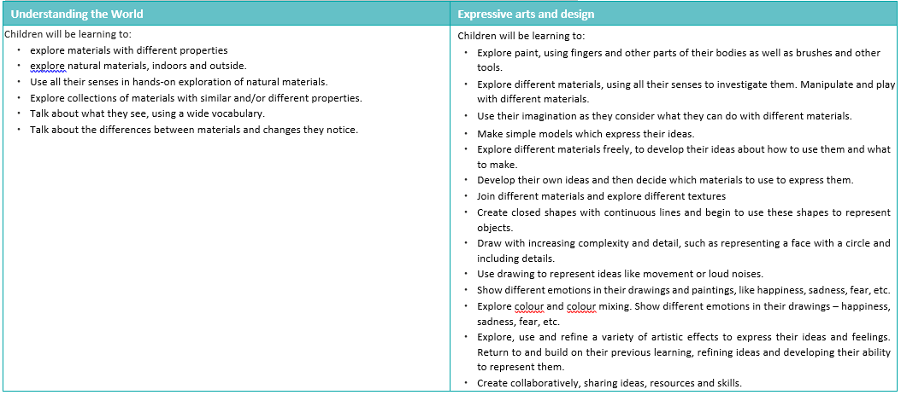

In Key Stage 1, children will build on these skills practiced in the Foundation Stage. The children undertake construction, mechanics, food, and textiles projects.

In Key Stage 2, they will also undertake construction, mechanics, food, and textiles projects. The children also have opportunities to investigate electrical systems and computing systems.

Planning will follow the process of design, make, evaluate, and improve. These key concepts enable pupils to reinforce and build upon prior learning, make connections, and develop subject specific language:

Design
- Use research and develop design criteria to inform the design of innovative, functional, appealing products that are fit for purpose, and aimed at particular individuals or groups.
- Generate, develop, model, and communicate their ideas through discussion, annotated sketches, cross-sectional diagrams, prototypes, pattern pieces, and computer-aided design.
Make
- Select from and use a wider range of tools and equipment to perform practical tasks (for example, cutting, shaping, joining, and finishing, as well as chopping and slicing) accurately.
- Select from and use a wider range of materials, ingredients, and components, including construction materials, textiles, and ingredients, according to their functional properties, aesthetic qualities, and, where appropriate, taste.
Evaluate
- Investigate and analyse a range of existing products.
- Evaluate their ideas and products against their design criteria and consider the views of others to improve their work.

Develop, Use and Apply Technical Knowledge
- Apply their understanding of how to strengthen, stiffen and reinforce more complex structures.
- Understand and use mechanical systems in their products.
- Understand and use electrical systems in their products.
- Apply their understanding of computing to program, monitor and control their products
- Understand some of the ways that food can be processed and the effect of different cooking practices (including baking and grilling).

The provision will support each child’s achievement of the ‘end-points’, as stated on the school’s Design and Technology Knowledge and Skills Progression Mapping documents, which are directly informed by the National Curriculum 2014, as below:
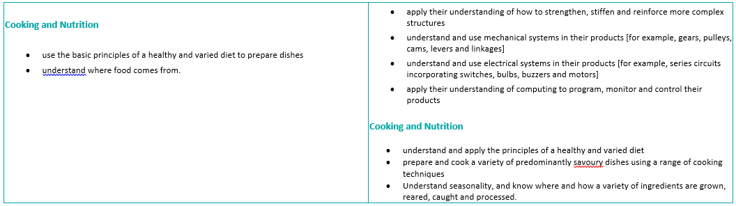
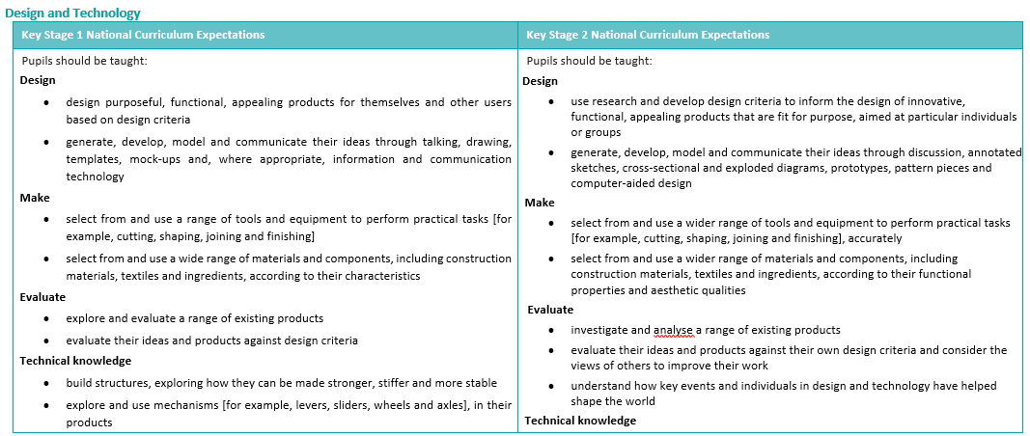

Impact

We ensure the children:
• Develop the creative, technical and practical expertise needed to perform everyday tasks confidently and to participate successfully in an increasingly technological world.
•Build and apply a repertoire of knowledge, understanding and skills to design and make high-quality prototypes and products for a wide range of users. Critique, evaluate and test their ideas and products and the work of others
• Understand and apply the principles of nutrition and learn how to cook. Children will design and make a range of products. A good quality finish will be expected in all designs and activities made appropriate to the age and ability of the child

- Teaching and Learning

Design and Technology will engage the children in a broad range of designing and making activities which involve a variety of methods of communication; speaking, designing, drawing, assembling, making, writing and using computer technology. Projects are taught in blocks which allows for more effective learning in which teachers can focus on teaching and developing DT skills, allowing children to develop their ideas and techniques. Units of work have been selected and planned to ensure a balance of materials, skills, knowledge and understanding throughout each Key Stage. All children should have a breadth and balance of experience.

The curriculum is designed to enable progression in Design and Technology processes, including specific aspects of designing and evaluating. It also ensures that children develop their knowledge and skills systematically; choosing and using an increasing range of tools and techniques to suit a range of different purposes and developing their knowledge and understanding of mechanisms and structures to enable the incorporation of mechanical and electronic systems into their products.

- Assessment

Children’s existing skills from previous year groups are built on throughout each new topic. Through the explicit teaching of the Design skills, both the teachers and the pupils assess their learning continuously throughout the lesson.

Learning is assessed through the analysis of the pupil’s ability to evaluate, design, make and improve their own work.

With reference to the progression outlined in the national curriculum, teachers have identified the key knowledge and skills that underpin progress in each unit of work. These build progressively throughout the school, and across the programme of study, and form the basis of assessment in Design and Technology.

Displays throughout school and on the school’s website will reflect a range of work across key stages, to celebrate children’s work.

- Planning and Resources

The key skills and knowledge for each Design and Technology Topic have been mapped by each year group to ensure that these are progressive from one year to the next. Planning considers cross-curricular opportunities and these are stated in the long term plans. The context of the school, including the use of local resources and places to ensure relevance, is also considered at the planning level.

Teachers will either select materials needed to complete a DT project from available resources within school, purchase any materials needed for the design, construction and evaluation of a project or decide to use recycled materials or junk modeling to help complete a project. Children are taught to use tools and equipment in a sensible, safe and efficient manner.

- Organisation

Design and Technology planning is mapped in blocks on the Whole School Curriculum Overview. Units of work are planned to include a balance of designing and making assignments, teaching key skills and work involving reviewing existing products. Links with other subject areas are made where appropriate.

- Equal Opportunities

We are an inclusive school that ensures all pupils are provided with equal learning opportunities, regardless of social class, gender, culture, race, disability or learning difficulties.

Whole school policy on equal opportunities will be adhered to in Design and Technology activities. Teachers ensure that children have access to the range of Design and Technology activities and use opportunities within Design and Technology to challenge stereotypes.
Children are encouraged and supported to develop their Design and Technology capability using a range of materials. Children with special needs or disabilities will be differentiated for and supported appropriately, to ensure development of skills and equal access to the Design and Technology curriculum.

- Inclusion

  - All children will be supported through differentiation, adaptation or adult support, to enable equal access to learning in Design and Technology.
  - Topic vocabulary is explained to the children with accompanying definitions and visual cues, to ensure that all children develop and can use a range of vocabulary according to the project.
  - QR codes, photographs and printouts/screenshots of tasks completed on a computer or app can be used to evidence a learning process where the child has not produced a recorded outcome.

- Role of the Subject Leader

The subject leader will monitor the teaching and learning of Design and Technology across the school; ensuring a high quality, broad and stimulating curriculum. They will also support and facilitate opportunities that support the continued professional development of teachers in the teaching and learning of Design and Technology. A range of good-quality materials and tools, which enable teachers to resource and teach the subject effectively, will be maintained by the subject leader.

- Parents

We encourage all parents and carers to support and assist with whole school events and Design and Technology projects. Parents and carers from the field of design and technology are warmly encouraged to approach the school to support opportunities for enrichment and the school will actively seek to engage and collaborate with parents and carers with specialist skills for this purpose.

This policy will be reviewed annually by the Governing body. Policy Agreed: 2025
Policy Review Date: 2026

nnnn

