Online reading books  •••  Use the Bug Club online books weekly for additional reading practice.  Find the login details in the back of your child’s reading diary.  See your child’s teacher if you need support. | Reading at home is important  •••  Your child should read their ‘phonics’ book to an adult 3-5 x per week minimum!).  Find a time that works for you… your child may find reading at the end of the day hard when they are tired. | 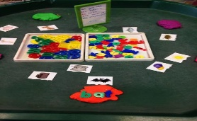  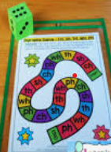  Playing games, helps your child practise all of their phonics skills in a fun way. They need lots of practise to recognise and recall phonemes individually and within words. | A guide to Phonics & Reading in Key Stage one    Sparken Hill Academy
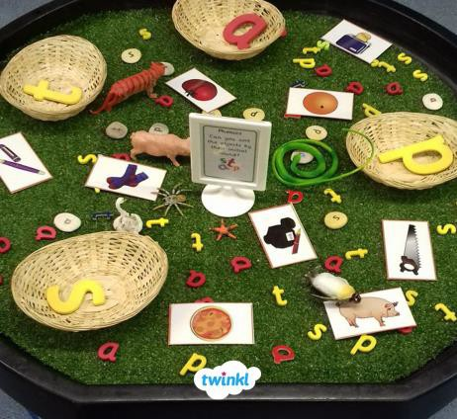  Try some sorting activities at home to help your child learn words that have the same sounds in but are spelt differently. We call these sound families. This will help with spelling. | What will we learn?  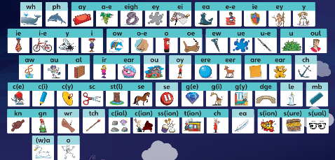  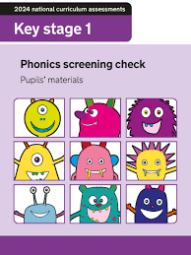  Phase 5 (Y1) Phase 6 (Y2)  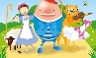 |   The Y1 phonics screening check will be completed in the week commencing the 8th of June in 2026. Ask your child’s teacher and teaching assistant what you can do at home to prepare children for this. |   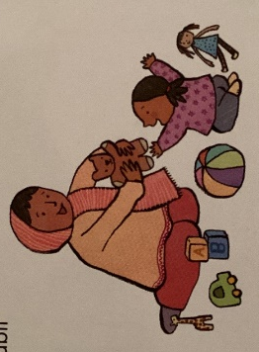    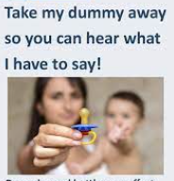  There is a time and a place for dummies, constant long term use can affect speech development.
 | 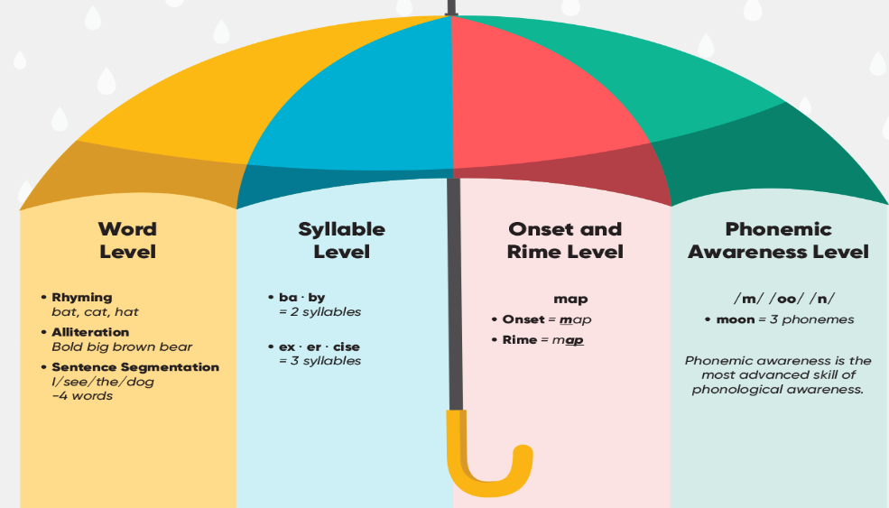 | Please send your child to school every day with their book bag  •••  This should include:  - A phonics book from school.  - A reading diary.  If you misplace these please ask your child’s teacher for a replacement.

Reading with your child:  •••  - Encourage them to sound out (segment) decodable words and then blend them together to read the whole word. You can model this if they need support.  - Encourage them to track the words with their finger as they read along. | When writing in your child’s reading diary please comment on either their:  - fluency  - comprehension (understanding) of the text  - segmenting & blending ability  - phoneme/tricky word recognition | 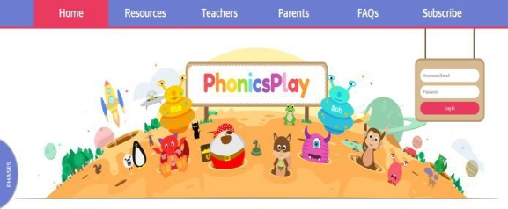  For reading and spelling practise, try these free educational games. These games can be played on smart phones, iPads, tablets and laptops. |   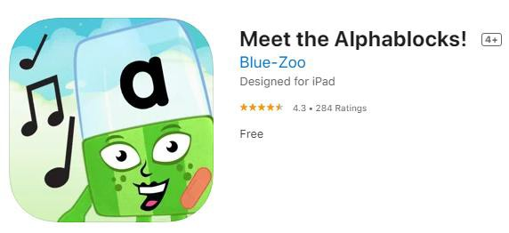  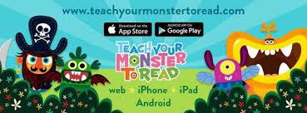
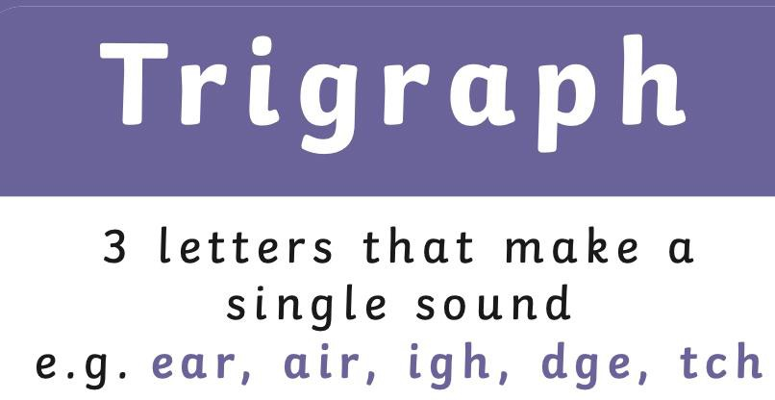  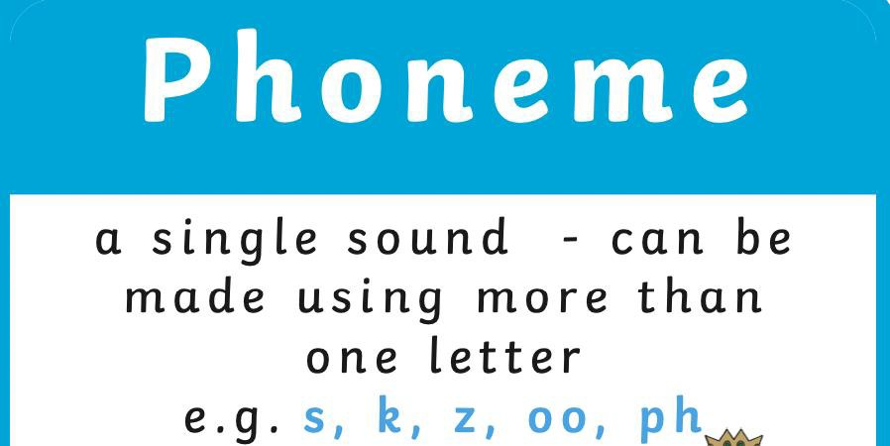  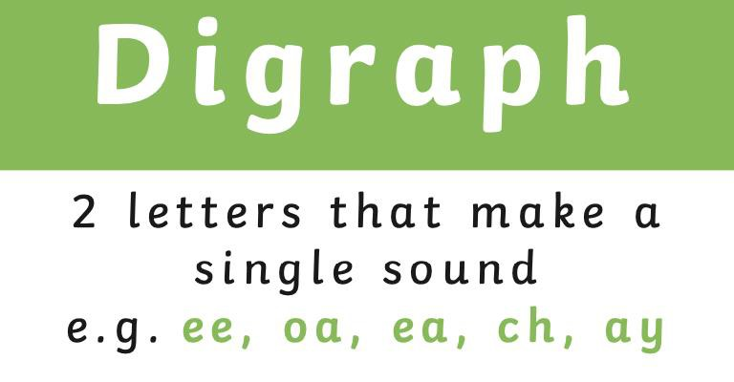  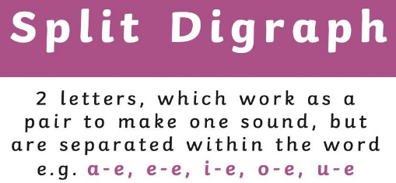  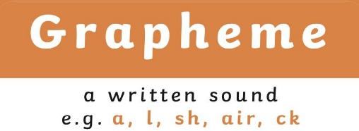 | Tricky words  •••  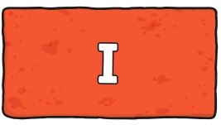  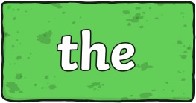  Tricky words are irregular and cannot be sounded out using the rules of phonics. Children are taught to memorise tricky words by sight.  Visit our school website class pages where you will find videos showing you how to help teach phonics skills at home (e.g. saying ‘pure sounds’, segmenting & blending) | •••  Look at ‘The National Curriculum (2014)’ to find out what your child’s developmental milestones are in Y1 and Y2  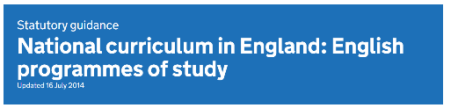    Segmenting is listening to how a word sounds and splitting it up into phonemes in order to write the word “s-p-oo-n”    Blending is joining the sounds together to help us to read a word “spoon”. | Reading with your child:  •••  - Give them some thinking time.  - Ask them questions (on the inside cover of the book) to check their understanding (comprehension).  If you ever need some help with phonics or have any questions, then please come and find us… Phonics today is very different to how we were taught at school and we understand it may seem confusing!

