


Year 3 & 4 Rainforest Homework
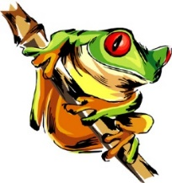
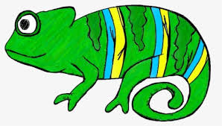

Each week, select something from the menu to do as homework – we hope you enjoy having a choice!

This term’s menu will be based on our new topic, ‘Rainforests’.

If you have a good idea for an activity based on the topic, but it’s not on the menu, then go for it - we would love to see it!

Homework books need to be returned to school on Thursdays. (earlier if completed sooner) They will be marked and sent out again on Friday.

We are looking for excellent presentation in each piece of work, please.

You can complete your homework independently, or with the help of an adult. It can be a lot of fun creating a project collaboratively, and as we know, we learn best together!

Remember, if you need extra resources, like squared paper or need to use the internet, talk to your teacher. We will do everything we can to help you.
Also, don’t leave your work to the last minute! Start it in plenty of time, then you have plenty of time to do your very best!

Our spelling and Times table tests will be each Thursday. You will be given new spellings each week to stick into your homework books.

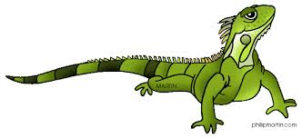

Create 6 ‘Did You Know?’ fact cards about the rainforest. | Write a poem about the rainforest. | Research an animal from the rainforest and write up the factual information in full, descriptive sentences.
Write a formal letter to the Government to persuade them to ‘save our rainforests’. | Design a crossword using rainforest keywords. | Write a short, descriptive story based on the rainforest.
Imagine you are an explorer in the rainforest. Write a diary based on the events that had taken place. | Write a non-chronological report about a rainforest animal of your choice (intro, habitat, appearance etc). | Write at least 6 sentences about the rainforest with a variety of sentence structures.
Create a rainforest board game. This can include facts, maths problems or spelling questions. | Write a rap about saving our rainforests. | Can you create a 2D/3D rainforest scene?
Create a word search using at least 12 rainforest keywords. | Create a 3D rainforest model. Use any materials you like. | Make a rainforest animal using a variety of materials.

