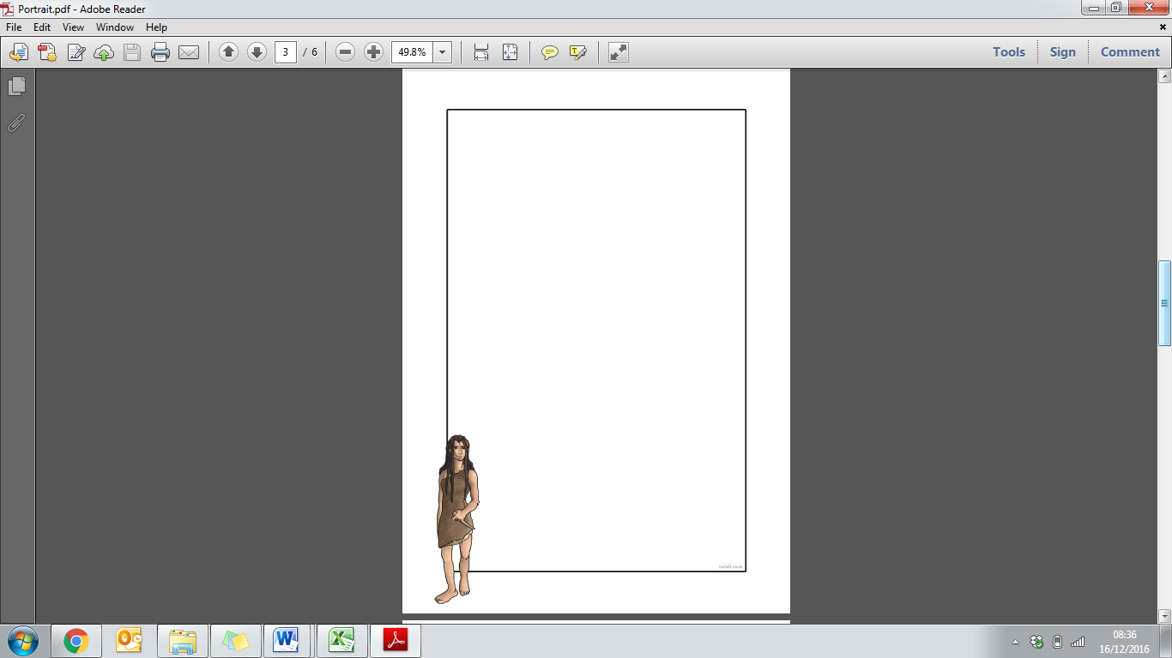
Year 3 & 4 Homework Menu – SPRING TERM

This term, we are learning all about the Stone Age. This fascinating topic incorporates our History and Science learning, as well as being weaved into much of our Art, English and Reading lessons.

We offer a wide variety of ways for your child to further and consolidate their learning at home.

Pupils should:
- Practise their times tables (5-10 minutes each day)
- Practise their spellings (5-10 minutes each day)
- Read with, or to, an adult (at least 3 times per week)

These activities are vitally important to the continued academic development of your child and we ask that these are your main focus.

In addition to these, this homework menu offers a range of additional projects you and your child could enjoy.

These are suggested activities, but if you have your own ideas linked to our topic, we would be delighted to see them!

Thank you for your continued support!

The Year 3/4 Team.

Research, draw and make notes about an animal that was around in the Stone Age. | What are flints? How were they made? What were they used for? | Compare what life is like today to what it was like in the Stone Age. What are the similarities and differences? Which age would you prefer to live in?
How did people first settle in this country during the Stone Age? How did they travel? Where did they come from? | Create a Stone Age timeline. How many years does the Stone Age period cover? | Find out and write a paragraph about the tools that were used in the Stone ages.
What did people wear in the Stone Age? Draw a picture and label. | Design and draw a Stone Age painting. What might be included in a Stone Age painting? What sort of things did they show? | Create a quiz about the Stone age.
Find out about Stonehenge. What is it? Where is it? Do we know who built it and why? Write about it or make a model. | Research how they built their homes in the Stone Age and what they were made of. | Create a leaflet about ‘How to survive the Stone age’.


