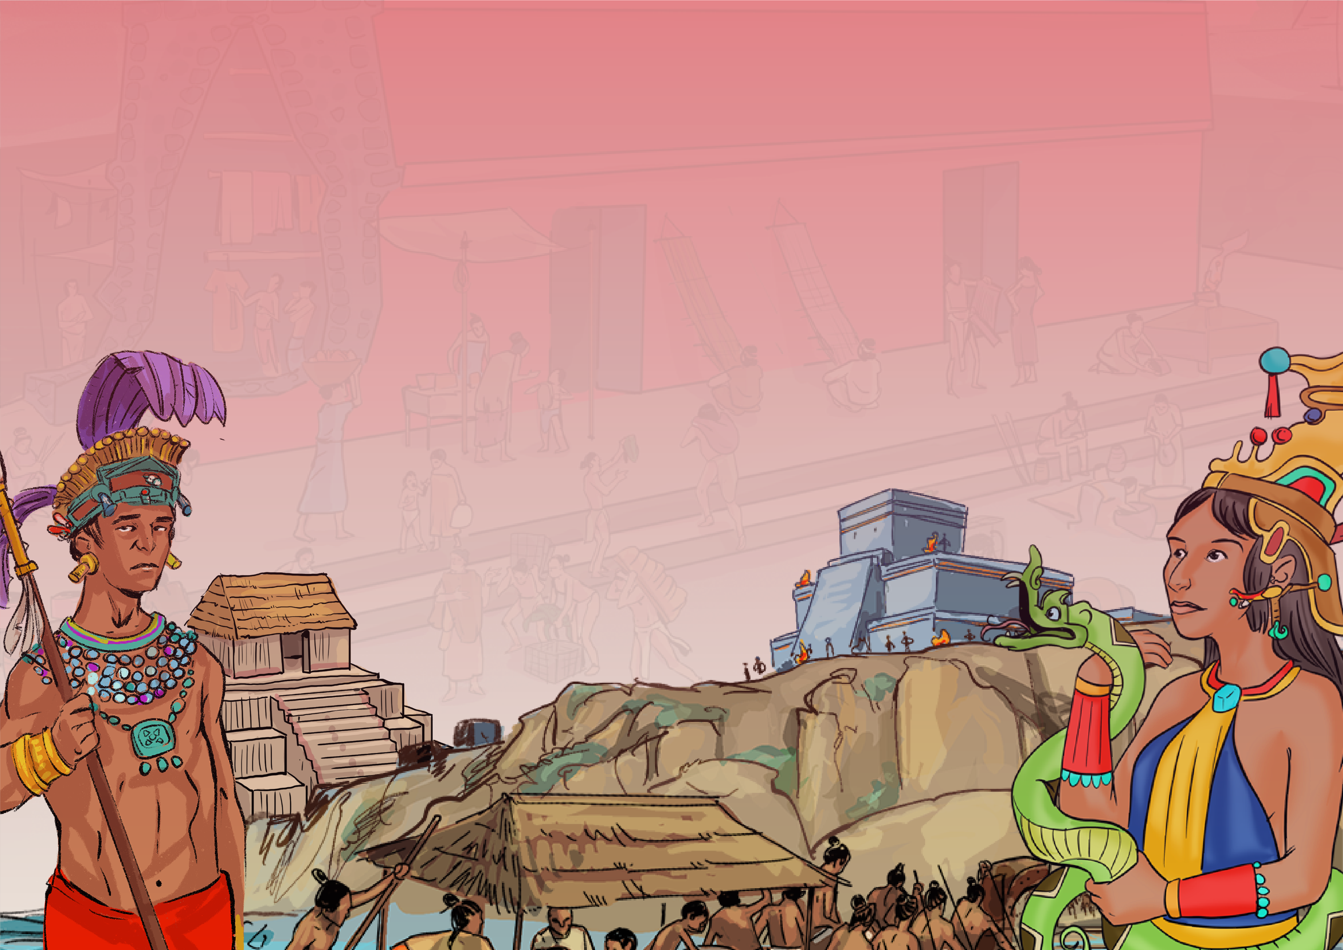
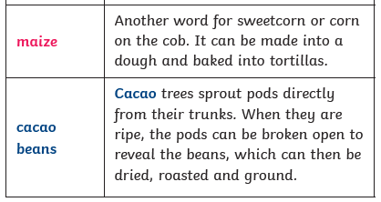
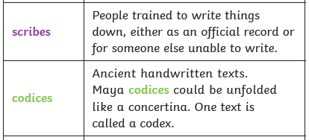
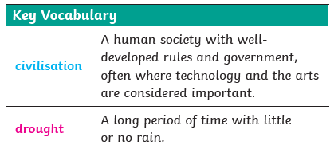
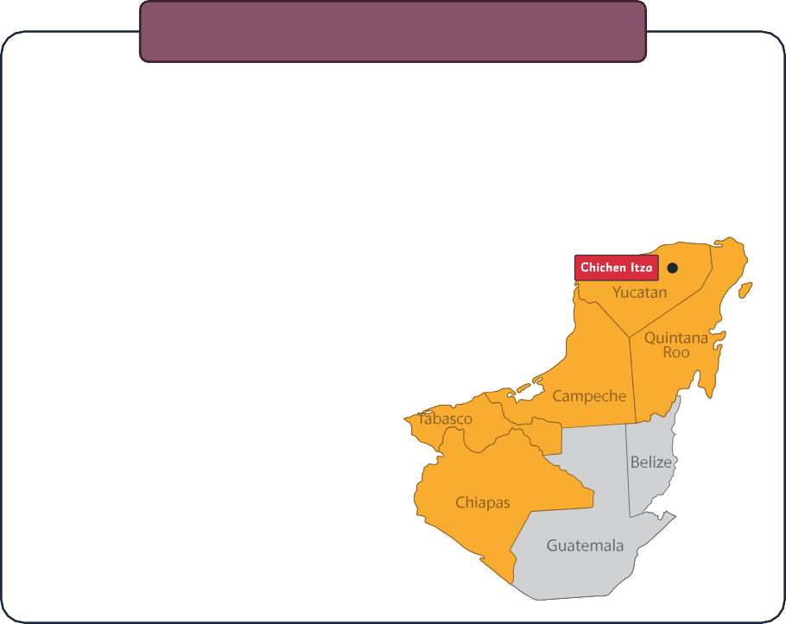


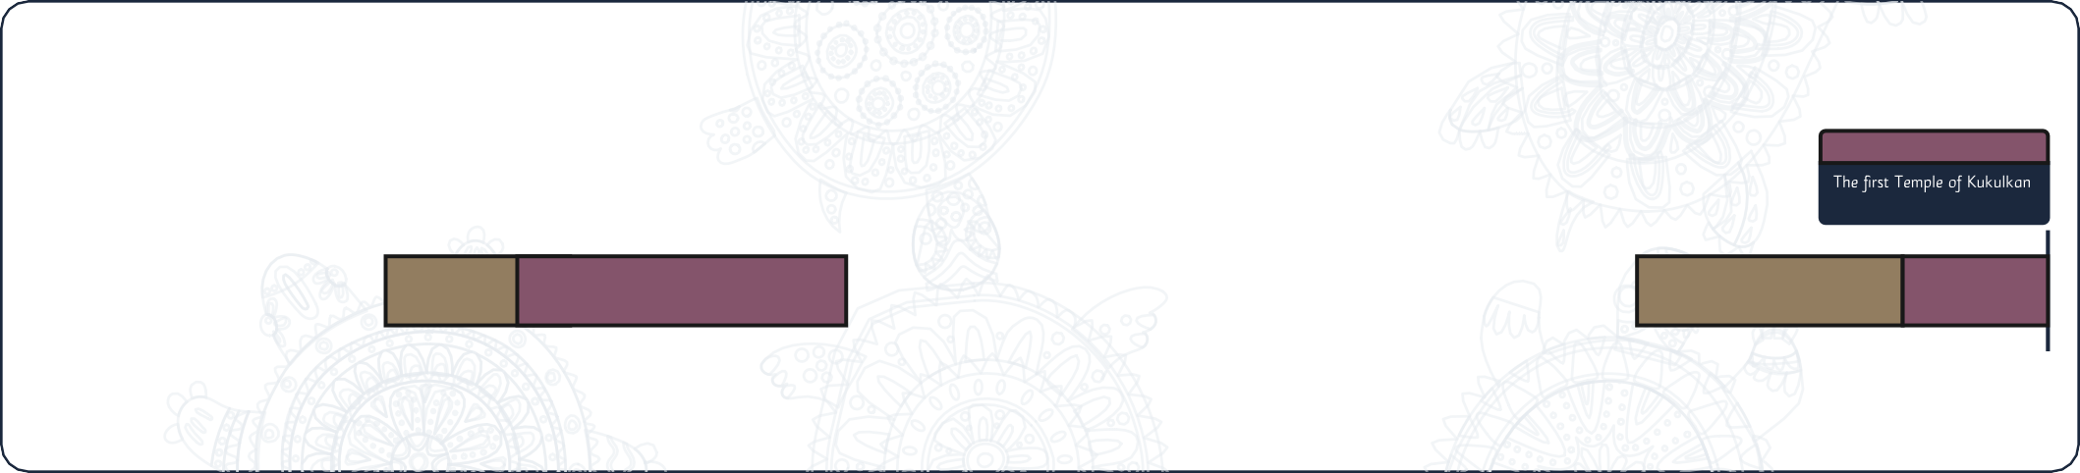
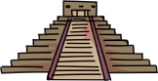

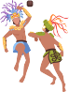
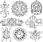
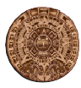
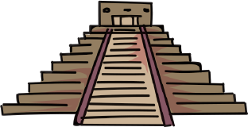
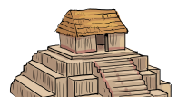
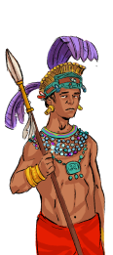
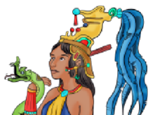
Cacao beans were used as a form of money to trade, used to make a bitter drink & medicine!
History: Y3/4 - The Ancient Maya Civilisation
We are focussing mainly on the ‘Classic Period’ as you can see this timeline spans over 12,000 years!
How do we know about the Ancient Maya?

We know about the Maya because archaeologists have found evidence of their existence. The Maya were famous for their wall art and beautiful writing. Many examples have been discovered over the years, and these two records give us an idea of what life was like for the different people in Maya society. There have also been many other archaeological discoveries of Maya tombs, funeral masks, architectural remains of the large city-states, and the famous stone pyramids that still stand today.
The Ancient Maya Civilisation
People have lived in this region for over 12,000 years, and when they settled here first, they were hunter-gatherers. This means they migrated across the land, searching for food and places to settle. Over time, these people learned to farm and settled in small villages. Eventually, these
grew into large city-states spread across
what would one day become Mexico,
Guatemala, Belize, El Salvador
and Honduras. These people
were called the Maya, and their
power and might reached their
height in the 10th century.
Maya
1500 CE
250 CE
950 CE
2000 BCE
8000 BCE
11,000 BCE
Paleoindian
The first Temple of Kukulkan Chichen Itza started.
Calendar
Writing
Pitz or Pok ta Pok (Maya ball game)
Domestication of corn
550 CE – 1100 CE
250 BCE
300 BCE
1000 BCE
3000 BCE
Classic
Post Classic
Preclassic
Archaic
Maya
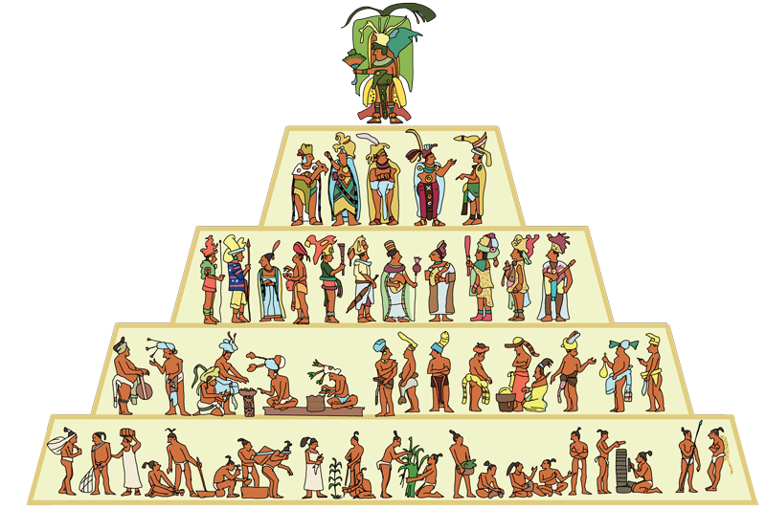
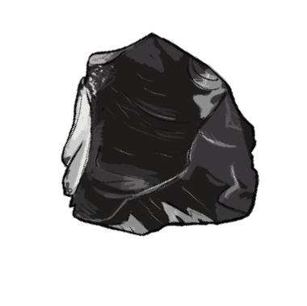
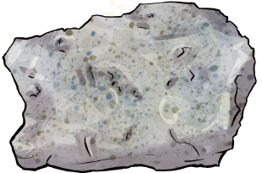
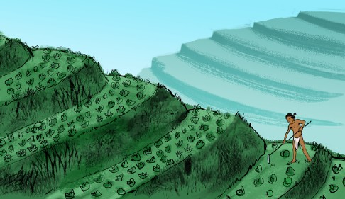
Over time, the city’s population grew, and the Maya built temples, ballcourts and plazas. These were attractive places to live and work and provided a place for the Maya people to worship their gods.
obsidian
limestone
Instead, each city was a state with its own ruler and council of high priests.

The Maya were not a united empire of people with a capital city like Ancient Egypt.

The city-states of the Maya often went to war with each other to prove that they were the strongest in the region.
Artefacts show historians and archaeologists that life was very different for the rich and poor in Maya society.

Nobles
Council (Priesthood)
Commoners - Farmers
(and Slaves)
Merchants and Artisans
King or High Priest (ajaw)
Who ruled the Maya people?
The Maya civilisation grew with
a plentiful supply of water, specialist farming techniques, and abundant natural limestone and obsidian for building materials and tools.
Farming was important for the Maya people. It was one of the main reasons that the civilisation grew and became so powerful. They developed many specialist farming techniques to help grow crops and invented a way of collection and storing water to irrigate their crops.
obsidian – a volcanic glass the Maya could sharpen to use as a tool.

The Maya lowlands were also filed with limestone – a perfect building material. They also had access to plenty of

Who ruled the Maya people?

How did the Maya civilisation become successful?

