Easter at Adventures
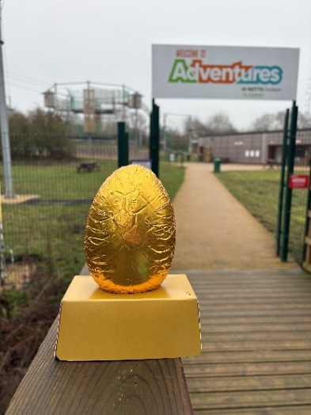
‘find the clues whilst 6m high’

Adventures await in the Easter holidays at King’s Mill Reservoir
If you’re looking for an amazing experience during the Easter break, head to
Adventures at Mill Waters! Open daily Sat 28 March – Sun 12 April.

The following activities are available:
- High Trek + (£18) ropes courses at 6m & 10m (including tricky obstacles and zip wires
- Net Park (£8)
- Zip Line Experience (£12) fly solo or with a friend on our dual 100m wires

And we will have our eggstra special ‘egg hunts’ at height available for a small extra fee!
- Follow our trail up high on our High Trek + to win a prize
- or bounce around our Net Park to find our clues to win a prize

Whether you're planning a family day out, or just looking to burn off some energy, this is the place to be. It’s all about fresh air, confidence building, and making lifelong memories.

Get 10% off activities using the code ‘SCHOOLSOUT26’. Standard booking terms and conditions apply.

We’re also available for:
- birthday parties
- team building days

📍 Adventures, Kings Mill Reservoir, Sutton-in-Ashfield, NG17 4PA
adventures@nottscc.gov.uk 0115 804 2603
Booking in advance is recommended but walk-ins are also possible if sessions have space
🌐 https://adventures.nottinghamshire.gov.uk

